NATIONAL POLAR-ORBITTING OPERATIONAL
ENVIRONMENTAL SATELLITE SYSTEM (NPOESS)
INTEGRATED PROGRAM OFFICE
8455 Colesville Road
Suite 935
Silver Spring, MD 20910


NPOESS Community Collaborative Calibration/Validation Plan for the NPOESS Preparatory Project
VIIRS Land Environmental Data Products

DATE: 22 May 2009 No. I30006
VER. 1 REV. A

PREPARED BY: ____________________________________________
Dr. Jeff Privette, NOAA/NESDIS/NCDC

ELECTRONIC APPROVAL SIGNATURES:

____________________________________ ___________________________________

____________________________________ ___________________________________

Prepared by  NPOESS Integrated Program Office | Prepared for  U.S. Department of Commerce  National Oceanic and Atmospheric Administration (NOAA)  National Environmental Satellite, Data, and Information Services (NESDIS)  National Polar-orbiting Operational Environmental Satellite System (NPOESS) Integrated Program Office (IPO)

Table of Contents
Objectives 3
1. Requirements for Mission Success 5
2. Product Priorities 6
3. General Approach 7
4. Shared Product Activities IN Pre-Launch Period 9
5. Major team activities by NPP validation phase 10
6. needs from the Integrated program office 12
7. Top Risks 12
8. Detailed Validation Plan By Product 12
Surface Albedo EDR 14
Land Surface Temperature EDR 20
Vegetation Index and Surface Reflectance 25
Cryosphere Products: Snow Cover and Depth 32
Cryosphere Products: Ice Surface Temperature and Sea Ice Characterization 38
Active Fires 47
Surface Type 53
Cloud Mask Over Land 59
10. Team Management 63
11. Operational User Outreach 64
12. General Schedule 64
appendix a. 65
NPOESS System Specification information and additional validation issues under consideration by Prime contractor 65
Surface Albedo EDR 65
Land Surface Temperature EDR 67
Vegetation Index and Surface Reflectance 69
Cryosphere Products: Snow Cover and Depth 71
Cryosphere Products: Ice Surface Temperature and Sea Ice Characterization 73
Surface Type 83

NPP Land Product Validation Team
Team Member | Institution | Role
Jeffrey Privette | NOAA NCDC | Team Lead
Chris Justice | University of Maryland | Team Co-Lead
Ivan Csiszar | NOAA/NESDIS/STAR | Active Fire SME*
Mark Friedl | Boston University | Surface Type SME
Alfredo Huete | University of Arizona | Vegetation Index SME
Jeffrey Key | NOAA/NESDIS/STAR at University of Wisconsin | Cryosphere Products SME
Alexei Lyapustin | UMBC at NASA’s GSFC | Surface Reflectance SME
James Maslanik | University of Colorado | Cryosphere Products SME
Joanne Nightingale | Innovim LLC at NASA’s GSFC | Coordinator; CEOS Liaison
Peter Romanov | University of Maryland at NOAA/NESDIS/STAR | Snow Cover and Depth SME
Crystal Schaaf | Boston University | Surface Albedo SME
Eric Vermote | University of Maryland | Cloud Mask SME
Yunyue (Bob) Yu | NOAA/NESDIS/STAR | Land Surface Temperature SME

Primary Collaborators
Team Member Institution Role: Bob Cook ORNL DAAC Validation Data Handling SME: Mike Ek NOAA/JCSDA Model Assimilation SME: John Eylander AFWA Model Assimilation SME: Robert Wolfe NASA GSFC Geolocation SME: Ranga Myneni Boston University Geolocation Gridding SME

*SME = Subject Matter Expert

Objectives

The National Polar-orbiting Operational Environmental Satellite System (NPOESS) Preparatory Project (NPP) (launch expected in 2011) and afternoon overpass NPOESS platforms (launches expected in 2014 and 2021) will each carry the 22-band Visible/Infrared Imager/Radiometer Suite (VIIRS). Data from VIIRS will be used to operationally generate a suite of land and cryosphere products, including Environmental Data Products (EDRs), Application Required Products (ARPs) and Intermediate Products (IPs). The products will be processed in the Interface Data Processing Segment (IDPS), which during the NPP era has operations at both NOAA’s Satellite Operations Facility (NSOF) in Suitland, Maryland and Air Force Weather Agency (AFWA) at Offutt Air Force Base in Omaha, Nebraska. This Land and Cryosphere Validation Plan (hereafter called the “Land Plan”), identifies the approaches that will be used to verify and validate the operational land and cryosphere products in the NPP era. In turn, the NPP activities are designed to be a pathfinder for a cost-effective and scientifically defensible ongoing validation program throughout the NPOESS era (nominally ending in 2027).
The VIIRS Land and Cryosphere Validation Team (hereafter “Land Team”) will validate a total of 14 different products within nine general product categories (see Table 1). In most cases, multiple data products -- each requiring a validation strategy, effort and investment -- comprise the general EDR. The Team also includes experts to provide guidance on several “upstream” algorithms critical to successful Land Products (e.g., Calibration, Geolocation, Aerosols, Cloud Mask).
Table 1. NPP Land and Cryosphere Product Categories Dependent on VIIRS, together with the associated Priority Category used to support NPOESS trade decisions.
Discipline | Sensor | General Product | Priority Category for NPP* | Number of VIIRS-based Products
Land/  Cryosphere | VIIRS | Land Surface Temperature (LST) | II-A | 1
Land/  Cryosphere | VIIRS | Surface Type | II-A | 2^
Land/  Cryosphere | VIIRS | Albedo (Surface) | II-A | 1#
Land/  Cryosphere | VIIRS | Vegetation Index | II-A | 2
Land/  Cryosphere | VIIRS | Sea Ice Characterization* (age) | II-A* | 1*
Land/  Cryosphere | VIIRS | Ice Surface Temperature (IST) | II-A | 1
Land/  Cryosphere | VIIRS | Snow Cover/Depth | II-A | 2
Land/  Cryosphere | VIIRS | Active Fires ARP | II-B | 2
Land/  Cryosphere | VIIRS | Surface Reflectance IP | N/A | 1

^ Surface Type validation covers the gridded Quarterly Surface Type IP and the vegetation greenness fraction parameter. Other parameters in this EDR are covered by the Active Fire and Snow Cover product validation.
# Surface Albedo EDR provides one data variable, it is stratified here by discipline (Land or Cryosphere) since the respective strata tend to utilize discipline-unique instruments, techniques and personnel. The EDR is unique in that two alternative estimates of surface albedo are provided in the standard EDR files. Both algorithms will be evaluated and characterized as part of the validation.

* Sea Ice Characterization EDR contains a variety of products, some of which require a microwave imager (e.g., MIS) to meet specification. The Sea Ice Age EDR is the primary NPOESS Sea Ice Characterization product to be validated. The Sea Ice Concentration IP, which is required for production of the Sea Ice Age EDR as well as the IST EDR, should also be validated to assist in understanding the Sea Ice Age EDR algorithm performance. The Ice Age EDR will be validated consistent with a comparable, recently-developed ice age product generated from AVHRR and MODIS. Note that the MIS-derived versions of ice products may have different priority categorization.

The Land Team will also monitor and product expert evaluation and advice on several upstream products that impact land product quality, including: Geolocation (a responsibility of the VIIRS Sensor Data Record [SDR] Validation Team), Aerosol Optical Thickness EDR (over land, a responsibility of the VIIRS Atmospheric Validation Team), and Cloud Mask IP (a responsibility of the VIIRS Cloud Mask and Imagery Validation Team).

Requirements for Mission Success

Each land product (EDRs, ARPs, and some IPs) has quantitative specifications determined by the NPOESS System Specification (see Table 2 for abbreviated specifications; full specifications, including various parameter stratifications and exceptions for degraded/excluded conditions are available elsewhere). These specifications represent the government’s contract with the prime contractor. The government’s operational users have identified a different set of requirements in the Interagency Operational Requirements Document 2 (IORD2). Some IPs (Surface Reflectance IP), while absent quantitative specifications, are of sufficient importance and interest to current operational user communities that their uncertainties must also be determined. Addressing these different validation criteria requires a prioritization of goals and activities. Therefore, Land Team will address these different validation program goals in the following order:
- Assess the operational viability of the EDRs, IPs, and ARPs. This task involves assessing the “reasonableness” of values (e.g., EDR scenes have values for a reasonable number of pixels, there is not excessive noise, stripes, drop-outs and spatial or temporal discontinuities, that retrieved parameter values are in the general range of expected values from the literature, common sense and existing operational products from POES, and that reflectances and radiances are positive-valued). The specific requirements for a given EDR are determined in partnership with the operational users and will be identified in more detail in future revisions of this Plan.
- Assess compliance of EDR, IPs, and ARPs with the IORD2. This task involves comparison with a variety of independent measurements, including those from concurrently operating satellites with validation products (e.g., MODIS products) as well as field measurements.
- Assess compliance of EDR, IPs, and ARPs with the VIIRS System Specification. This involves a more rigorous comparison of EDRs with independent measurements, as well as estimated uncertainties of the comparison. Achieving this level of validation is the primary goal of the Team’s planned activities.
- Determine the quantitative uncertainties of EDR, IPs, and ARPs at Stage 3 Validation (comprehensive range of environmental conditions). This task involves attempting to identify the uncertainties as a function of many variables, including surface-atmospheric regime, phenological stage, sun-view geometry, etc.

Table 2. The Land EDR’s and their associated performance metrics from the VIIRS System Specification. Note that additional specifications typically apply to each EDR, such as Revisit Time, Coverage, Long Term Stability and Mapping Uncertainty; for brevity, these are not listed here. Further, each EDR has an associated Exclusion Conditions (e.g., high solar zenith angles) for which its specifications are relaxed. See Appendix for details.
EDR | Horizontal Cell Size  (nadir) [km] | Precision | Accuracy | Uncertainty
Land Surface Temperature (LST) | 0.75 | 0.5 K | 2.4 K | N/S
Surface Type | 1.0 | N/S | N/S | 70% (PCT*)
Albedo | 0.75^ | 0.02 | 0.03
Active Fires (ARP) | 0.75 | N/S | N/S | 50 K (subpixel temperature)  30% (subpixel area)
Vegetation Index | 0.375** | 0.02** | 0.016 (NDV)  0.11 (EVI) | 0.11 (TOC EVI)
Surface Reflectance IP && | 0.375 (I##),0.75 (M) | N/S | N/S | <0.01#
Snow Cover/Depth | 0.4 (binary)  0.8 (% cover) | N/S | N/S | 90% (binary PCT*)  10% (% cover)
Ice age | 2.4 | N/S | N/S | 70% PCT (ice free, new/young, other)
Ice concentration (MIS) | 20 | N/S | N/S | 1/10
Ice surface temperature (IST) | 0.8 | N/S | N/S | 0.5 K
Ice motion | 3 | N/S | N/S | 1 km/day
N/S=No value specified.
*PCT=Probability of Correct Typing
^ Product is reported and delivered at 0.75 km, however the performance is specified at 4 km resolution.
## I=Imagery band, M=Moderate resolution band
**Accuracy and precision apply to NDVI only. EVI does not have these specifications.
&& Derived requirements for Intermediate Products are not contractually binding.
# Surface Reflectance IP requirements are derived as specified in VIIRS Chain Test Report – The VIIRS Land Algorithms Document, Number: D44204: 30 March 2007

Product Priorities

The Land Team will validate all VIIRS-based land and cryosphere products during the NPP era. However, the Team will put a heightened initial emphasis on products that characterize sensor performance or that provide time-critical hazard information that potentially impacts the safety of human life:

- Active Fire Detection, which potentially impacts human safety,
- Surface Reflectance IP, to assess VIIRS visible/near-infrared performance, and
- Land and Ice Surface Temperature, to assess VIIRS thermal infrared performance.
- Sea Ice Characterization, which affects safety of shipping operations in the Arctic.

Thereafter, the Team will emphasize the performance of products that impact other NPP EDR products, including:

- Surface Type, an input to the Land Surface Temperature algorithm, and
- Vegetation Index, an input to the Surface Type and Cloud Mask algorithms

Thereafter, the Team will address products that with larger user communities before addressing all remaining products.

General Approach

Because the NPP VIIRS Land and Cryosphere products are so diverse (from sea ice to active fire characterization) and numerous (14 archived products, including EDRs, APRs, and IPs with known user communities), their validation requires a broad set of dedicated activities and expertise. Land and cryosphere validation is particularly challenging due to the major expected and unexpected temporal changes in spectral and structural properties (e.g., due to vegetation phenology, episodic snow/fire/water inundation, diurnal snow/water/ice transitions, and variations in sea ice cover over even shorter time periods). The challenges are complicated by the parameters, often discrete, spatial transitions (e.g., around pivot irrigation systems or urban structure) and the resulting unique need to appropriately “scale up” point measurements with fine resolution imagery (e.g., Landsat). Because Land (which hereafter also includes cryosphere) products concern society’s immediate living environment, they are particularly important to understand and correctly characterize.

To address these challenges, the Land Team has developed a plan that leverages existing EOS and operational program investments and, during the NPP era, defines a clear path towards a cost-effective validation throughout the NPOESS era. Besides ensuring the operational utility and quantitative performance of the products, the present Land Team Plan builds toward the new CEOS validation protocols as defined through the Working Group for Calibration and Validation (WGCV) and its subgroups. The Land Team is committed to regular participation in the CEOS WGCV Land Product Validation Subgroup. This provides a medium for validation community outreach, as well as insights into state of the art methods, tools, data handling and collaboration opportunities.

The Land Team works closely with the NASA Land PEATE and NASA NPP Science Team, which together pursue the related goal of assessing the usefulness of VIIRS Land products for NASA’s climate research needs. Indeed, several members of the Land Validation Team are members of the NASA NPP Team. The relationship allows the Land Validation Team to leverage the PEATE’s tools and large-scale product generation capabilities in exchange for expert support, analysis and data handling (including field data provision in some cases). In the pre-launch time frame, the relationship allows the Land Team to acquire and analyze VIIRS Proxy Data generated from (and later compared to) MODIS data. In the post-launch time frame, the relationship will be particularly valuable for testing and regenerating VIIRS products using corrected or improved algorithms. The Land Validation Team will ensure that the PEATE and IDPS algorithms are in sync as needed for assessing the VIIRS operational algorithm performance (an agreement is in place to ensure appropriate and timely coordination). It is envisioned that, over time, the PEATE tools and capabilities will be ported to and validated in the IPO’s GRAVITE system for long-term maintenance and access. However, given the complexity of these tools, the institutional expertise is significantly greater in the PEATE and therefore of lower risk to the Land Team’s success.

To date, the Land Team has developed and begun implementing this Plan without extensive negotiations with the NPOESS prime contractor. Schedule and opportunity has thus far not allowed that. However, the prime contractor is required, by contract, to validate the NPP/NPOESS products to meet system specifications. Therefore the Land Team will commence dedicated discussions with the prime contractor in June 2009 (4th Global Vegetation Workshop, Missoula) such that opportunities for collaboration and cost-sharing can be identified and exploited.

As noted above, a primary and rapid approach to validating VIIRS products will be through comparisons with their MODIS, AVHRR and other satellite system counterparts. The Land Team is working with the PEATE to ensure this can be conducted efficiently and appropriately (e.g., via reprojecting data as needed). In tandem with comparisons with MODIS and AVHRR products, the Land Team is pursuing other proven validation techniques (e.g., comparison with in situ data) that can be economically sustained past the end of the MODIS and/or AVHRR eras. We describe the four techniques, with the associated Land and Cryosphere Products below:

  - POINT Location Validation: Albedo (Land), Land Surface Temperature, Vegetation Index, Surface Reflectance IP, Snow Cover/Depth, IST, Ice Motion
Validation data can be acquired using ground-based instruments in fixed locations, often as part of large field networks. Drifting buoys are included in this category. These data tend to be operationally quality-checked and archived using standard formats, metadata and documentation.
  - Remote Sensing Validation: Sea Ice Characterization, Ice Surface Temperature, Albedo (Cryosphere)
Validation data are typically acquired by research investigators using satellite data along with specialized sensors onboard manned and unmanned aircraft. The latter data tend to take more time and resources to be geolocated, quality-checked and archived, and may or may not adhere to standard formats, metadata and documentation. The aircraft operations are sometimes augmented by in-situ observations.
  - Episodic Remote Sensing Validation: Active Fires
Validation data are typically acquired by operational agencies (e.g., national fire services) or research investigators using specialized aircraft sensors, or by tasked acquisition satellite systems (e.g., Landsat). Depending on the source, these data can take a variable amount of time and resources to be geolocated, quality-checked and archived, and may or may not adhere to standard formats, metadata and documentation.
  - Classified Remote Sensing Validation: Surface Type, Sea Ice Characterization
Validation data are typically acquired by tasked acquisition, fine resolution satellite systems (e.g., Landsat, Hyperion, RADARSAT, ENVISAT, ICESat). Images must be independently classified and validated before being useful for VIIRS validation. The process can take a variable amount of time and resources, and may or may not adhere to standard formats, metadata and documentation.

Shared Product Activities IN Pre-Launch Period
Although each of these methods has been successfully demonstrated with other satellite systems, significant new work is required prior to NPP launch to ensure they are mature and ready to support NPP VIIRS validation, and that they can be sustained over the NPOESS era at a relatively low annual cost. Some of these apply to a large number of products, and are therefore summarized here rather than listed within multiple specific product validation plans (further below). The shared interest activities include:

- Field Campaigns
Field campaigns were, for most land products, the mainstay of the MODIS validation programs. They were effective, however they were also expensive given the logistical planning, travel, field equipment procurement, and data post-processing. Under the NPP/NPOESS program, the Land Team seeks to minimize field campaigns and instead rely on operational field networks whenever possible. However, the latter data sources are not necessarily proven for satellite validation use, and some pre-launch path finding campaigns are necessary around field network sites to “bridge” EOS and NPP validation techniques. Therefore, the Land Team will conduct a small number of campaigns in 2009 and 2010 that are specifically focused on understanding the fixed operational measurements (e.g., those at a SurfRad site) in the context of the traditional measurements (including research instrumentation) used during EOS. Further, several products (IST and Fire) depend primarily on field campaigns for validation. The SMEs for these products will therefore conduct focused campaigns to test the instruments and procedures to be applied to VIIRS on-orbit data. In every case, we will seek to cost-sharing or collaborative opportunities with NASA, DoE, NSF, USFS, BLM and MMS partners as appropriate.

- Extension and Maintenance of the MODLAND Imagery Data Base
Since about 1998, the MODIS Land Team has been acquiring remote sensing and other data sets to support validation around the EOS Land Validation Core Sites. The data set is now extensive, and includes ancillary information (e.g., land elevation), aircraft and satellite remote sensing data (e.g., IKONOS, Landsat, ASTER), and other data (e.g., AVHRR Pathfinder). The EOS Core Sites do not always have permanent instrumentation and other infrastructure as needed to support NPP VIIRS validation. Nevertheless, there is some overlap with the CRN, ARM, SurfRad/BSRN, AERONET, Greenland Climate Network (GC-Net) and Antarctic automated station networks. As appropriate, this set will grow to include Ameriflux/FLUXNET and Surface Radiation Baseline Network (SRBN; a planned aggregation and standardization of the U.S. BSRN, STAR and other small networks) data. Therefore, the NPP Land Validation Team will extend this rich remote sensing database to include the base NPP validation networks listed above. This will primarily include the systematic acquisition of Landsat, ASTER and other free or very low cost tasked acquisition, fine resolution imagery. Further, as the EOS program begins to wind, the Land Team will work with NASA to support the ongoing maintenance and upkeep of this unique data archive and its support services (e.g., web sites, data distribution capabilities). The potential also exists to further exploit several of the core sites and other networks to provide validation data useful for cryospheric products (IST, albedo and snow fraction in particular). Specifically, this may include extracting cryosphere data from existing data sets, and possible augmentation of sites with additional instrumentation.

- Site Characterization and Scaling Assessment
In contrast to the MODIS validation strategy, the NPP Land Validation Plan is focused on exploiting operational field network data to the greatest extent possible. However, whereas field campaigns can be organized around “ideal” remote sensing targets (e.g., large homogeneous tracts of land, snow cover or shore-fast ice), the operational field networks are rarely in optimal locations. For example, they are often close to urban infrastructure or close to Surface Type boundaries. Therefore, as part of the Land Team’s initial focus activities, we will systematically quantify the large area (multiple kilometers) heterogeneity around all field network sites of potential interest for validation. The geostatistical method to be employed was recently developed and demonstrated by investigators at Boston University. The procedure also quantifies the relative representativeness of tower measurements at a site relative to the VIIRS pixel area, given the existing tower height and instrument field of view (among other variables). By conducting this study at the onset, the Land Team will be able to concentrate its post-launch Intensive Cal/Val activities only on those sites for which success in scaling is likely. Details of the Characterization and Scaling procedure are discussed below under the detailed plan for Surface Albedo validation.

- Satellite Product Evaluation Center (SPEC)
Since 2007, NOAA’s NCDC has been working with NASA’s Oak Ridge National Laboratory (ORNL) DAAC on the Satellite Product Evaluation Center (SPEC), a validation tool that interactively compares data sets retrieved in near real-time from the respective archives. The tool takes advantage of state of the art web services, including OpenDAAC, SOAP and other technologies. It is particularly user friendly in that it subsets in space and time “on the fly”, potentially allows investigators to compare in situ, remote sensing and model output data at any location (or over areas) for any period with minimal effort. Currently, SPEC is being further developed and will be catered to use with VIIRS products (NCDC is the official national archive for all RDRs, SDRs, EDRs, distributed IPs and other NPP data and information). SPEC includes both visual output and raw data dumping, and includes a series of statistical tools to help users understand the differences between data sets. The statistical tools are being modified to incorporate information on the uncertainties of the ground “truth” data sources. Current plans are to allow SPEC to run both as an interactive tool for scientists or data searchers, and in “background mode” such that it continuous evaluates VIIRS products against independent data sets and reports its findings only as requested by the user. Further, SPEC will be suitable for validation of non-Land products, including those for Atmospheres, Oceans, etc.

Major team activities by NPP validation phase

In the pre-launch period, the key activity for the Land team will be to fully characterize the algorithm performance. This will include identifying existing and emerging algorithm performance issues, team familiarization with the NGAS developed algorithm error budget, resolving outstanding algorithm issues, and identifying key measurement needs to address any unresolved issues.

A major component of these early validation activities is the tight integration with the NASA Land PEATE. Partnerships with other agencies—such as NASA, the ORNL Data Active Archive Center [DAAC] for Biogeochemical Dynamics, NOAA’s National Climatic Data Center (, NOAA/STAR, the Department of Defense meterological users, and the Joint Center for Satellite Data Assimilation (JCSDA) f—must be developed and fostered.
Algorithm testing at global and selected test sites will be performed for comparison purposes. The algorithms to be addressed include the VIIRS science and operational algorithms. Such assessment and verification will focus on proxy MODIS data for VIIRS retrievals, with attention being paid to comparison with MODIS Collection 5, various AVHRR products, and a variety of in situ data sources described below.
The NGAS team has been actively engaged in evaluation activities for the past 6 years. Their pre-launch phase cal/val activities will consist of interacting with the government teams in their efforts, developing detailed implementation plans for validation to contractual specifications, tracking sensor characterization and calibration issues during thermal vacuum testing and incorporating them into plans were needed In addition, the software tools that had been used for pre-launch performance predictions, based on limited test data sets, will be enhanced and automated in preparation for the post-launch data sets.
Data sets will be constructed and compared to key validation match-up data sets, such as those deriving from MODIS, AVHRR, AERONET/ASRVN, FLUXNET, SurfRad, CRN, and other field networks, as well as episodic data sets such as from cryospheric field campaigns, fire aircraft remote sensing data from the US Forest Service. For Surface Type products, we will make extensive use of land cover classified imagery emanating from the Landsat program.

Permeating all these activities is the need for descriptive and prescriptive statistics and physical insight and understanding to help characterize geometric, geographical, seasonal, and phenomenological dependencies.
The Team will also complete validation site characterization and implementation of the appropriate scaling methodology, and validate the scaling techniques in the field through one or more multi-product field campaigns. Representativeness and consistency of the initial on-orbit products will be assessed.

In the post-launch Intensive Cal/Val period, Land Team will seek to conduct similar targeted campaigns – preferably with VIIRS operating in diagnostic mode. This period will include rigorous comparison and evaluation against heritage products from contemporaneous MODIS, AVHRR and GOES data (e.g., albedo, NDVI). Methods and use of operational field data sets will be demonstrated during this period. The Team will work closely with the Land PEATE to understand impacts of constrained pixel growth and onboard aggregation per the section below (“CHARACTERIZATION OF THE VIIRS AGGREGATION MODES”).

During the long-term monitoring phase, Land Team will increasingly rely on operational field station data including CRN, SurfRad, BSRN, ARM, Aeronet, GC-Net and others, as well as episodic LDCM and U.S. Forest fire imagery as available. As available, NIC/NISE/NORCH snow and ice products and NASA research satellites will be employed. Calibration/validation efforts for other new systems such as CRYOSAT-II and NASA’s planned “ICESat Gap Filler” campaign will also be leveraged to provide additional data sets and routes for international data sharing. The goal in this period will be to ensure and monitor product quality of C1 and other NPOESS satellites.
Consistent with its archive-based program, Land Team will facilitate development of a data flow architecture and tools necessary to ensure NPOESS cal/val data, including that from other sensors and disciplines, can be stored and redistributed in a low cost and efficient fashion. This will include tools for near real time routine comparison of NPOESS EDRs with operational field measurements.

needs from the Integrated program office

The IPO is currently developing a list of primary users for each EDR; Land Team will consult with those users to review their cal/val requirements. Presently, the Land Team has established communication with the joint NOAA-NASA-DoD Joint Center for Satellite Data Assimilation (JCSDA; via Mike Ek), including NASA LDAS/LIS group, as the AFWA operational user group (via John Eylander).

The Land Team also expects the IPO in initiate dialog with NASA management on cooperative/collaborative targeted pre- and post-launch validation exercises to ensure EOS validation “technology insertion”.

Top Risks

- The loss of MODIS Aqua prior to completing the NPP Intensive Cal/Val period would increase the latency and cost of Land Product validation. The loss of both MODIS Terra and MODIS Aqua in that time frame would significantly compound the problem. The loss of MODIS Terra, with no change in MODIS Aqua operations, would not significantly change the Land Team’s plans or costs. Reduced access to data from non-U.S. satellite sensors such as ENVISAT would negatively impact validation of sea ice products.

- The future status of NASA’s Land PEATE is not clear. Currently, we believe the PEATEs will be re-competed and presumably extended, however the loss of the PEATE prior to completing the NPP Intensive Cal/Val period would lead to a significant loss of capability.

- The funding for field measurement networks (CRN, AERONET, BSRN, SurfRad, Ameriflux/FLUXNET, and ARM sites including the Barrow, Alaska facility) must be ensured over the long term (complete NPP/NPOESS era). Each of these is critical to the Land Team’s success, and is particularly important for sustained low cost validation following the end of the MODIS era.

Detailed Validation Plan By Product

Below we provide detailed descriptions of VIIRS product validation strategies on a product-by-product basis. These specific plans complement the more general plans and strategies outlined above. For convenience, this plan provides hyperlinks as follows:
- Albedo (Surface)
- Land Surface Temperature
- Vegetation Index
- Surface Reflectance IP
- Snow Cover/Depth
- Sea Ice Characterization
- Ice Surface Temperature
- Active Fires ARP
- Surface Type
- Cloud Mask Over Land
- Characterization of the VIIRS aggregation modes

Surface Albedo EDR

Validation Drivers

The VIIRS Surface Albedo EDR provides two estimates – from two distinct algorithms -- of the instantaneous ambient broadband albedo at each 750 m. The main algorithm (so-called Bright Target Surface Albedo [BPSA]) is a new and relatively untested regression-based approach which estimates surface albedo directly from the top-of-atmosphere reflectances (SDR). The alternative algorithm (so-called Dark Target Surface Albedo [DPSA]) is based on the current MODIS backup algorithm. This algorithm requires as input bidirectional reflectance distribution information as collected over the previous 16-days (or climatology). The NPOESS prime contractor has stated that the BPSA output will be considered the official albedo product. Given its lack of heritage, however, we will put significant emphasis on comparing the alternative estimates such we can recommend the approach that is demonstrably superior.

The Surface Albedo product definition for an instantaneous daily surface albedo quantity is unique from the MODIS systematic albedo products, which provide intrinsic directional hemispherical reflectance (DHR, or black sky albedo) or bi-hemispherical reflectance (BHR, or white sky albedo). However, an equivalent MODIS “blue sky albedo” can be determined as a combination of the DHR, BHR values and aerosol optical depth. The MODIS blue sky albedo and the VIIRS product are equivalent to the ratio of measurements from a downward and an upward-facing pyranometer (paired as an “albedometer”).

Tower mounted albedometers are used to measure global radiation (direct plus diffuse) or diffuse-only radiation in the spectral range from 0.3 to 3.0 µm. Several operational field networks contain tower albedometers, and therefore provide inexpensive and proven independent data for Surface Albedo EDR validation.

The inter-satellite comparisons will be facilitated with the Satellite Product Evaluation Center (SPEC) tool, a prototype of which was developed in 2007 in a joint endeavor between NOAA’s NCDC and the ORNL DAAC. An advanced version of SPEC, which will work with parameters from all disciplines (ocean, atmosphere, etc.), provide cloud detection, and operate in both interactive and “background/anomaly detection” mode, is currently in development. This plan’s dependence on existing and sustained measurements collected by external programs allows sustained validation information in a more cost-effective manner relative to episodic field campaigns (employed sometimes during MODIS albedo validation). Further, the tools, resources and expertise that will be employed for VIIRS albedo validation leverage EOS investments, as well as tools developed for VIIRS LST validation (e.g., SPEC).

The VIIRS Albedo EDR will provide important information on the land surface energy budget for both regional and global weather forecast models. The ECMWF has already implemented a MODIS spectral albedo derived radiation approach and is exploring a more dynamic implementation (Morcrette et al., 2008).

Various other weather forecasting, data assimilation, and climate modeling groups are making use of gap filled MODIS albedo and BRDF products (Lawrence and Chase, 2007) while several other operational satellite products (King et al., 2003; Zhang et al., 2006; Friedl et al., 2002) rely on MODIS BRDF products to provide clear sky initial conditions (as do the VIIRS cloud cover and optical properties products). Disappointingly, the broadband VIIRS product will not allow routine access to the underlying spectral BRDF IP limiting its usefulness; however a comprehensive validation program will provide the information needed to achieve the greatest applicability of the VIIRS EDR.

Activities Required To Meet Exit Criteria

We will employ two primary approaches for Surface Albedo validation. First, we will compare VIIRS albedo values with those derived from MODIS Terra and Aqua. BRDF and albedo-derived MODIS Blue Sky albedo values – which are comparable to the VIIRS instantaneous albedo counterparts -- are easily calculated given aerosol optical depth information. Second, we will compare VIIRS albedo values against appropriately scaled in situ measurements collected by operational field networks, especially NOAA’s SurfRad and the Department of Energy’s Atmospheric Radiation Measurement (ARM) site(s) in the Southern Great Plains and North Slope. Although there are only seven sites in this network, their usefulness was developed and demonstrated with EOS MODIS data.

The Baseline Surface Radiation Network (BSRN; Ohmura et al., 1998; McArthur, 2005) provides continuous, long-term measurements of surface radiation fluxes adhering to the highest achievable standards of measurement procedures. The BSRN data, archived at World Radiation Monitoring Center at the Alfred Wegener Institute, Bremerhaven, Germany, is now recognized as the GCOS baseline network for surface radiation (GCOS, 2004). Among the more than 40 active stations around the world, only 15 currently also measure reflected radiation (Roesch, 2004) and thus provide data at a high temporal resolution for albedo calculations. These data have been used extensively to validate the MODIS products (Jin et al., 2003a;b; Salomon et al., 2007). Recent validations (Liu et al., 2009) have indicated that the MODIS product can be appropriately used to reconstruct even hourly albedo quantities during full daylight hours if the aerosol optical depth is known to be fairly low (see Figure 1) and the tower site is appropriately representative of the larger satellite pixel.

Although BSRN tower sites provide the highest-quality measurements, their sites do not provide representative global coverage as required for scientifically defensible EDR validation. In the U.S., the NOAA SURFRAD and DOE Atmospheric Radiation Measurement (ARM) efforts and other terrestrial research networks have appropriate tower sites with the necessary infrastructure (e.g. human maintenance, radiation instrument availability, site accessibility, and power needs) to augment the BSRN data set. Additional albedo data is often available through flux network towers (e.g. Ameriflux, CarboEurope) or international long term ecological research sites (ILTER). However, compared to BSRN, these networks do not all employ best practice measurement, calibration and archive protocols, or necessarily provide timely data access. In addition to radiation measurements, vital atmospheric state measurements (such as aerosol optical depth) needed to correlate surface and satellite-based quantities are also collected at many of these sites as part of regional or global meteorological or atmospheric networks (such as the Aerosol Robotic NETwork - AERONET). Under NPP, we will more strongly interrogate data from these sites to gain insight into algorithm behavior and develop credible error budgets.

Unfortunately, field albedo measurements are usually not directly comparable to the coarser-scale VIIRS EDR (especially at 4km). Except in a perfectly homogeneous case, the representativeness of an albedometer measurement is a complex function of the instrument height above canopy top, local surface type variability, canopy 3-dimensional structure, and a variety of less important variables. To combat the scale mismatch and provide better spatial representation, various albedometer “upscaling” methods have been utilized, ranging from the use of in situ measurements to the use of higher resolution satellite data and models (Barnsley et al., 2000; Liang et al., 2002; Baret et al., 2005). The NPP SME (Schaaf et al.) has developed a protocol that uses seasonal high resolution imagery of a site to establish several measures of spatial heterogeneity at various pixel resolutions. By taking into account the tower height and albedometer field of view, we can ascertain whether a tower measurement is truly representative of the much larger satellite pixel and can be used for direct validation (Figure 2). Otherwise the site may not be appropriate for use as a validation site or a spatial mixing or weighting may be required before the field data can be effectively compared with the satellite data. The representativeness of a site will change seasonally and is particularly hard to establish during periods of ephemeral snow cover. The identified sites will be applicable for both NPP and NPOESS validations although the sites must be monitored to identify any that undergo significant land cover change.

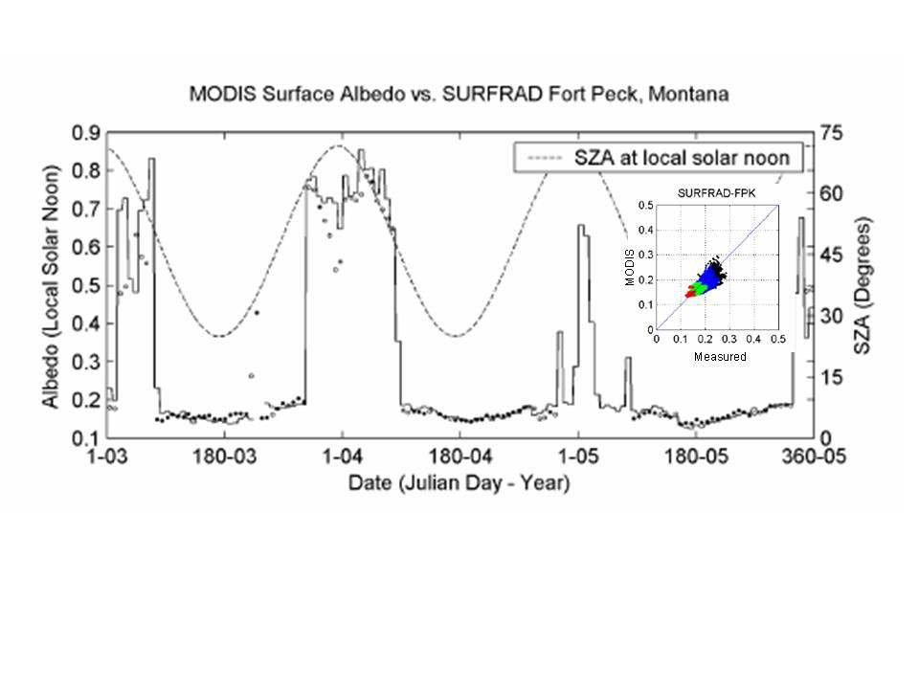

Figure 1. Time series of land surface albedo at local solar noon for the SURFRAD station at Fort Peck, Montana (SURFRAD-FPK) from 2003 to 2005. Inset scatter plot of measured ground albedo versus MODIS albedo for all sky conditions and retrieval quality (red szn<30º; green 30-50º; blue 50-70º degrees; black 70-90 ºdegrees (Liu et al., 2009).

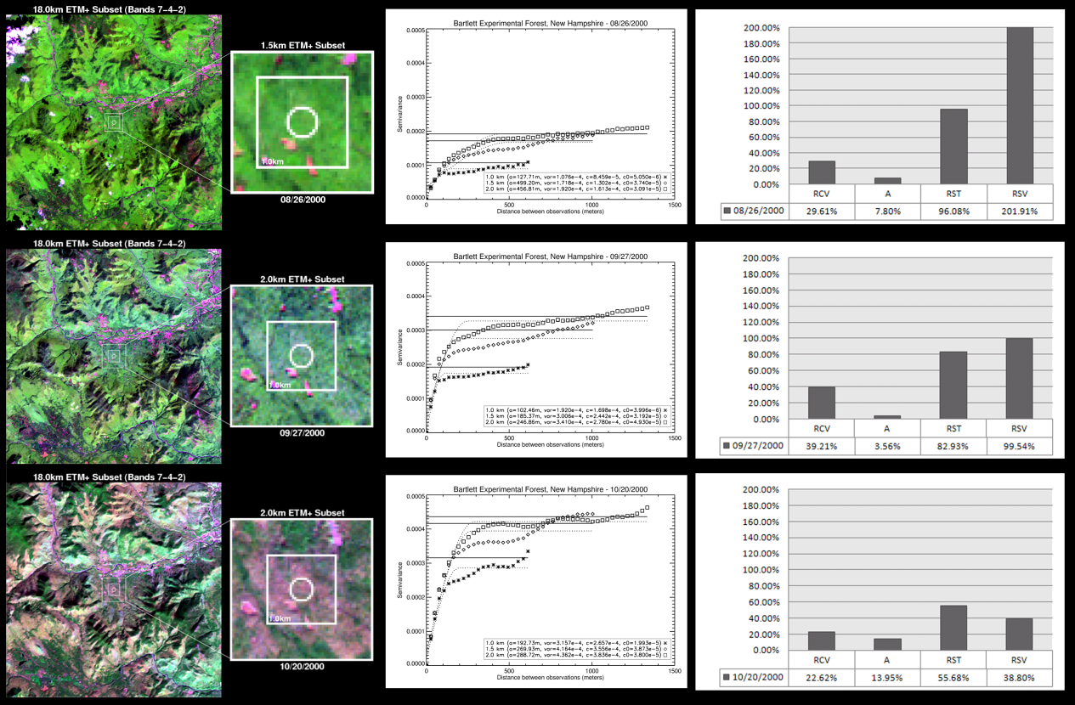

Figure 2. Top-of-Atmosphere (TOA) shortwave reflectance composites (ETM+ Bands 7-4-2) centered over Bartlett Experimental Forest for three time periods, illustrating conditions of maturity (26 August, 2000), early-senescence (27 September, 2000), and dormancy (20 October, 2000). Results for each geostatistical attribute (R_{CV}, A, R_{ST}, and R_{SV}) and the corresponding semivariogram functions are also available for each ETM+ retrieval. Trees are green and bare areas pink.

By applying this spatial-representativeness protocol to an expanded selection of sites within a variety of global biomes, a consistent series of tower sites will be identified that can serve as validation sites. Seasonal high resolution imagery (primarily Landsat) will be needed to specify representativeness over an annual time frame. Ideally these sites would be globally distributed in a systematic fashion but realistically we will need to investigate all towers, which collect albedo data and then attempt to stratify those that do by biome. Additional towers can be advocated for regions that are not measured.

Milestones Toward Exit Criteria

- Application of the validation site protocol to determined an extended roster of field sites, which are appropriately representative of a large enough footprint to validate satellite derived albedo products (at a 1km and greater spatial resolution). These sites will encompass a range of biomes.
- Establish the seasonal applicability of these sites.
- Inter comparison of the VIIRS products with other satellite derived products (e.g. MODIS)
- Inter comparison of the VIIRS albedo products with field data from the validation field sites over time, capturing both seasonal and ephemeral variations.

Time Required to Perform Activities

We have defined a 5-year development and implementation plan, which will allow us to demonstrate and prove a globally valid approach using VIIRS proxy data, then conduct near real time VIIRS EDR validation during the NPP Intensive Cal/Val period. After the Intensive period, we plan to execute a significantly lower cost “maintenance validation” and long-term trending phase that leverages the early investments and developments.
- FY2009
  - Conduct site characterization and scaling studies on SurfRad and 20 CRN
  - Conduct hypothetical site characterizations assuming CRN or SurfRad tower extensions
- FY2010
  - Conduct site characterization and scaling studies on additional CRN sites and address characaterization across four seasons.
  - Perform comparisons between site data and MODIS heritage results.
- FY2011
  - Test CRN and SurfRad data in SPEC using MODIS, AVHRR and Proxy VIIRS data
  - Evaluate proxy VIIRS data from PEATE
  - Develop documentation
  - Begin on-orbit VIIRS to MODIS comparisons
  - Support development of on-orbit coefficient tuning with Prime Contractor
- FY2012
  - Continue on-orbit evaluations against MODIS and AVHRR data
  - Participate in post-launch field campaign at CRN or SurfRad site to ensure validity and usefulness of point station measurement vis-à-vis wider area “campaign” measurements.
  - Identify and conduct site characterization and scaling studies on additional worldwide sites such as from Fluxnet or BSRN
  - Analyze results
- FY2013
  - Continue on-orbit evaluations against MODIS and AVHRR data
  - Conduct site characterization and scaling studies on world-wide sites under seasonal conditions
  - Analyze results

Bibliography

Baret, F., Schaaf, C., Morisette, J., and Privette, J. 2005. Report on the Second Int. Workshop on Albedo Product Validation. The Earth Observer 17 (3): 13-17.

Barnsley, M. J., P. D. Hobson, A. H. Hyman, W. Lucht, J.-P. Muller, and A. H. Strahler, Characterizing the spatial variability of broadband albedo in a semi-desert environment for MODIS validation, Remote Sens. Environ., 74, 58-68, 2000.

GCOS. 2004. Implementation plan for the Global Observing System for Climate in support of the UNFCCC. Report GCOS – 92 (WMO/TD No. 1219). 136p.

Jin, Y., C. B. Schaaf, C. E. Woodcock, F. Gao, X. Li, A. H. Strahler, W. Lucht, S. Liang, Consistency of MODIS surface BRDF/Albedo retrievals:Algorithm performance, J. Geophys. Res., 108(D5), 4158, doi:10.1029/2002JD002803, 2003a.

Jin, Y., C. B. Schaaf, C. E. Woodcock, F. Gao, X. Li, A. H. Strahler, W. Lucht, S. Liang, Consistency of MODIS surface BRDF/Albedo retrievals: 2. Validation, J. Geophys. Res., 108(D5), 4159, doi:10.1029/2002JD002804, 2003b.

Lewis, P. and Barnsley, M.J., (1994) Influence of the sky radiance distribution on various formulations of the Earth surface albedo, in Proc. Sixth ISPR Int. Symp. on Physical

Liang, S., H. Fang, M. Chen, C. J. Shuey, C. Walthall, C. Daughtry, J. Morisette, C. Schaaf and A. Strahler, Validating MODIS Land Surface Reflectance and Albedo Products:Methods and Preliminary Results, Remote Sens.Env., 83, 149-162, 2002.

Liang, S., (2000) Narrowband to broadband conversions of land surface albedo, I Algorithms. Remote Sensing of Environment, 76, pp 213- 238.

Liu, J., C. Schaaf, A. Strahler, Z. Jiao, Y. Shuai, Q. Zhang, M. Roman, J. A. Augustine, E. G. Dutton, Validation of MODIS Albedo Retrieval Algorithm: Dependence of Albedo on Solar Zenith Angle, J. Geophys. Res., in press 2009.

McArthur, L.J.B., BSRN Operations Manual V2.1, WCRP 121, WMO/TD-No. 1274, April 2005, www.wmo.ch/pages/prog/wcrp/PG_Reports_WCRPSeries.html

Measurements and Signatures in Remote Sensing, Val d'Isere, France, Centre National d'Etudes Spatiales, pp. 707-715.

Ohmura A., Dutton, E., Forgan, B., Frohlich, C., Gilgen, H., Hegne, H., Heimo, A., Konig- Langlo, G., McArthur, B., Muller, G., Philipona, R., Whitlock, C., Dehne, K., and
Wild, M. 1998. Baseline Surface Radiation Network (BSRN): New precision radiometry for climate change research. Bull. Am. Met. Soc. 79: 2115-2136.

Pinty B., Lattanzio A., Martonchik J.V., Verstraete M., Gobron N., Taberner M., Widlowski J.L.,Dickinson R.E., and Govaerts, Y.,(2005) Coupling Diffuse Sky Radiation and Surface Albedo, J. Atm. Sci. 62, pp. 2580–2591.

Roesch, A., C. Schaaf, and F. Gao, 2004, Use of Moderate-Resolution Imaging Spectroradiometer bidirectional reflectance distribution function products to enhance simulated surface albedos, J. Geophys. Res., 109, D12, doi:10.1029/2004JD004552.

Salomon, J., C. B. Schaaf, A. H. Strahler, F. Gao, Y. Jin, Validation of the MODIS Bidirectional Reflectance Distribution Function and Albedo Retrievals Using Combined Observations from the Aqua and Terra Platforms, IEEE Trans. Geosci. Remote Sens. Vol. 44, 2006.

Smith W.L., Charlock T.P., Kahn R., Martins J. V., Remer L. A., Hobbs P. V., Redemann J. and Rutledge C. K., (2005) EOS Terra Aerosol and Radiative Flux Validation: An Overview of the Chesapeake Lighthouse and Aircraft Measurements for Satellites (CLAMS) Experiment, J. Atm. Sci., 62, pp. 903–918.

Xiong X., Stamnes K. and Lubin D., (2002) Surface Albedo over the Arctic Ocean Derived from AVHRR and Its Validation with SHEBA Data, J. App. Meteo., pp. 413–425.

Return to Product List

Land Surface Temperature EDR

Validation Drivers

The NPP VIIRS Land Surface Temperature EDR contains one product: the instantaneous radiometric temperature of the earth surface (750 m resolution) – i.e., the algorithm provides corrections for both the atmospheric effects and surface emissivity. The algorithm is relatively complex and without heritage. The VIIRS LST main algorithm, that is developed and tested by private industry using model data, is a major variant of traditional split window (SW) approaches. Specifically, the algorithm employs a “dual-split window” (DSW) approach that depends on two middle infrared and two thermal infrared bands; different DSW algorithmic forms are used for day and night; and coefficients of the DSW algorithm, for daytime and nighttime, are stratified with the IGBP surface types. To our knowledge, this was the first application of DSW approach to LST. Further, VIIRS retains a new SW algorithm as a backup algorithm. Depending on the day/night status of the earth target and, for daytime pixels, the view direction’s proximity to the sun-glint vector, one of three formulations is used to estimate the LST. Each of the formulations has an associated set of predetermined coefficients stratified by Surface Type (IGBP) class.

Unlike its MODIS counterpart, the VIIRS LST algorithm does not depend explicitly on surface emissivity. Instead, the equation coefficients were developed based on an estimated emissivity distribution for the given surface type. Thus, the VIIRS algorithm does not allow for intra-class or temporal emissivity variability, and does not attempt to normalize by view angle (i.e., provide nadir values). Both the switchover of algorithms around the sun-glint angle and the switchover of coefficient sets across Surface Types could introduce performance discontinuities in LST maps that are not based on actual environmental changes.

To assess discontinuities, we will primarily compare the VIIRS LST against the MODIS counterpart since the latter dynamically retrieves emissivity and therefore would not suffer from either Surface Type coefficient or sun glint area algorithm changes. For quantification of VIIRS LST errors, we will focus on comparisons against data from operational field networks, including NOAA’s Climate Reference Network (CRN) and Surface Radiation (SurfRad) network. The comparisons will be facilitated with the Satellite Product Evaluation Center (SPEC) tool, a prototype of which was developed in 2007 in a joint endeavor between NOAA’s NCDC and the ORNL DAAC. An advanced version of SPEC, which will work with parameters from all disciplines (ocean, atmosphere, etc.), provide cloud detection, and operate in both interactive and “background/anomaly detection” mode, is currently in development.

Aircraft flights are generally not critical for LST validation over most Surface Types and climatological regimes, however there is one key exception: thermal infrared imagery of homogeneous tall canopies below atmospheres with strong water vapor and/or aerosol loading (e.g., rainforest canopies). Those particular conditions are challenging to LST split window algorithms, have well known surface emissivities (therefore allowing assessment of the atmospheric correction part of algorithm), and are nearly impossible to sample with tower or field instrumentation. Therefore, the extra cost and complexity of aircraft data acquisition may be justified for such conditions.

This validation plan’s dependence on existing and sustained measurements collected by external programs allows sustained validation information in a more cost-effective manner relative to episodic field campaigns (the mainstay of MODIS LST validation). Further, the tools, resources and expertise that will be employed for VIIRS LST validation leverage EOS and GOES-R investments, as well as tools developed for VIIRS Surface Albedo validation (e.g., SPEC, site heterogeneity characterization).

Activities Required To Meet Exit Criteria

We will employ two primary approaches for LST validation. First, we will compare VIIRS LST values directly with those of the MODIS Aqua LST (uncertainty <1 K, per: http://landval.gsfc.nasa.gov/ProductStatus.php?ProductID=MOD11 ), AATSR LST and other high quality validated satellite LST products (possibly including those from geostationary sources such as GOES-R ABI and MSG SEVERI). Second, we will compare VIIRS LST values against appropriately scaled in situ measurements collected in operational field networks, including NOAA’s Climate Reference Network (CRN) and SurfRad. This will include use of binned match-up data pairs. The latter approach will be implemented over a statistically significant number of sites and in an ongoing manner. Therefore, assuming a Gaussian distribution of errors in the site to VIIRS LST comparisons and rigorous error budget analysis, the mean VIIRS LST accuracy and precision can be determined and monitored over the NPOESS era. As the number of observations grows with time in orbit, we will stratify results to estimate performance per IGBP landcover and under the degraded conditions identified in the System Specification.

Milestones Toward Exit Criteria

To achieve the above goals during the NPP era, three developments must be pursued and implemented in the NPP prelaunch and early post-launch period.
- During the NPP prelaunch period we will extensively test the VIIRS algorithm on proxy VIIRS data generated from MODIS by leveraging capabilities of the NASA Land PEATE. The PEATE has already developed and demonstrated a Linux “wrapper” version of the official VIIRS operational LST algorithm. In preparation for this testing, we recently developed highly tuned MODIS-to-VIIRS spectral transformation algorithms that are Surface Type dependent and which utilize two or more MODIS bands to optimally estimate a single VIIRS band. Besides comparing MODIS vs. proxy VIIRS LST values, we will in particular test the sensitivity of the VIIRS algorithm to the formulation and coefficient discontinuities mentioned above.
- Also during the NPP prelaunch period, we will extend the site heterogeneity characterization and scaling study – described below for Surface Albedo – in preparation for validating the VIIRS LST against operational field network data. The characterization study rigorously quantifies both the representativeness of a given “point scale” field measurement with the larger surrounding area (commensurate with VIIRS pixel sizes, or larger), as well as the overall site heterogeneity. The approach, which leverages Landsat, ASTER and other fine resolution satellite images and advanced geostatistics, will objectively identify the sites in the CRN, SurfRad and possibly other networks where measurements can be compared most credibly with VIIRS LST values. As part of this study, we will attempt to choose a subset of sites that provides a reasonable Surface Type and/or climatological representation of actual global distributions. The study will also provide a scientifically sound and site-specific approach for scaling up the given point measurements for comparison with the VIIRS EDR. The site characterization study may be continued in the post-launch and long-term validation periods, for accurate correction to seasonal and annual variation.
- During the intensive Cal/Val period (with 6 months after launch) we will checkout the ABI LSTs by comparisons to ground measurements from SurfRad stations and the MODIS LSTs. We will evaluate the ABI LSTs in terms of the temperature regional distribution and monthly variation. Major product quality issues will be examined and carried out into long-term monitoring period.
- We will assess the configuration changes needed at select CRN sites -- in tandem with the representativeness assessments discussed above -- such that the LST sensor views more representative footprints. The standard site configuration includes an Apogee LST sensor at about 1.5 m above ground height. With a ~50 degree field of view, the Apogee target is clearly very small. However, the CRN tower bases were specifically designed to accommodate tower extensions. As we determine promising sites based on area homogeneity, we will work with CRN managers to extend select towers and put the Apogee sensors at more useful heights (e.g., 10 m). We will support these changes with one or more field campaigns using portable LST instrumentation that was developed and demonstrated as part of EOS LST validation campaigns. This will allow us to quantify the additional uncertainties inherent in using a single fixed operational LST sensor vs. an array of (or portable) research-grade LST sensor (e.g., that developed by S. Hook at JPL). The latter tests will provide a bridge the robust techniques used during the EOS era with more cost-effective techniques sustainable throughout the NPOESS era. The assessment of site configuration changes will be performed through out the pre- and post- launch periods.

Three potential needs are not addressed with this relatively low cost approach: 1) development of VIIRS LST algorithm coefficients using actual field measurements, 2) directional adjustment of the field and/or satellite observations such that they agree, and 3) validation of inland and coastal water bodies. Coefficient development is currently planned by the Prime Contractor, however it is not clear that a credible path towards this goal is defined. The directional adjustment is desirable since several studies have confirmed LST angular anisotropy. Nevertheless, current models of such anisotropy are still in the research phase and require significant manual activity to implement (e.g., determination of canopy and landscape structural properties). The Team is unaware of any distributed in situ measurements of inland and coastal water surface temperature. Therefore, to estimate performance, the Team will work with Simon Hook (JPL) who collects continuous in situ data over Salton Sea and Lake Tahoe (low altitude, shallow and high altitude, deep lakes in California, respectively) to estimate VIIRS LST performance on those two water bodies. Given the consistency of water emissivity, these lakes should indicate the range of product performance for inland water.

Time Required to Perform Activities
We have defined a 5-year development and implementation plan, which will allow us to demonstrate and prove a globally valid approach using VIIRS proxy data, then conduct near real time VIIRS EDR validation during the NPP Intensive Cal/Val period. After the Intensive period, we plan to execute a significantly lower cost “maintenance validation” and long-term trending phase that leverages the early investments and developments.

- Year 1 (2009-2010)
  - Initial generation and analysis of proxy VIIRS LST data sets
  - Conduct site characterization and scaling studies on SurfRad and 20 CRN sites for maximum green conditions
  - Conduct initial tests of CRN or SurfRad tower extension and LST sensor repositioning
  - Continue SPEC development
- Year 2 (2010-2011)
  - Evaluate discontinuities across sun-glint and Surface Type borders using proxy VIIRS data from PEATE
  - Conduct site characterization and scaling studies on remaining CRN sites for maximum green conditions
  - Continue SPEC development
  - Implement CRN or SurfRad tower extension updates at multiple sites (TBD)
- Year 3 (2011-2012)
  - Test CRN and SurfRad data in SPEC using MODIS, AVHRR and Proxy VIIRS data
  - Evaluate evaluation of proxy VIIRS data from PEATE
  - Conduct site characterization and scaling studies on CRN and SurfRad sites for senescent conditions
  - Search of foreign tower sites suitable for LST validation
  - Develop documentation
  - Begin on-orbit VIIRS to MODIS comparisons
  - Support development of on-orbit coefficient tuning with Prime Contractor
- Year 4 (2012-2013)
  - Continue on-orbit evaluations against MODIS and AVHRR data
  - Conduct post-launch field campaign at CRN or SurfRad site to ensure validity and usefulness of point station measurement versus wider area “campaign” measurements
  - Conduct site characterization and scaling studies on foreign sites for green and senescent conditions
  - Analyze results
- Year 5 (2013-2014, Long-term Monitoring Period)
  - Continue on-orbit evaluations against MODIS and AVHRR data
  - Conduct site characterization and scaling studies on additional foreign sites for green and senescent conditions
  - Analyze results
  - Begin automating processes and systems for Long-Term Monitoring
  - Begin C1 VIIRS LST analysis

Return to Product List

Vegetation Index and Surface Reflectance

Validation Drivers
Validation of the Surface Reflectance IP and Vegetation Index EDR requires highly accurate independent knowledge of the surface spectral reflectance. As with other products, continuity and consistency of the VIIRS VI with heritage products will be evaluated through comparisons with their MODIS- and AVHRR-derived counterparts.
Quantitative validation data can be gathered using low-altitude aircraft underflights of satellites or ground-based reflectance measurements. An alternative approach is to use accurate AERONET measurements of atmospheric aerosol and water vapor to perform an independent rigorous atmospheric correction of satellite measurements and compare derived reflectance and Vegetation Indices against their equivalent satellite products. Compared to ground-based (aircraft) measurements, this approach has several advantages. Because the generated ground truth data have the same spectral and spatial resolution as the satellite product, it avoids a complicated problem of spatial (spectral) scaling. Furthermore, this method provides directional reflectances, consistent with the satellite measurement, thus avoiding bidirectional corrections that would have to be made with ‘nadir-based’ ground and aircraft measures. This approach is applicable to a relatively large area around an AERONET site, rather than to a single point, which allows conducting more rigorous spatial analysis. The AERONET in-situ measures of atmosphere also readily facilitate retrievals of “nadir” top-of-canopy reflectances and VI’s, which are useful in validation and characterization of higher level, temporally composited and/ or BRDF modeled VI and reflectance products. Finally, because of the AERONET global infrastructure (over 160 sites globally), this validation approach will cover virtually all environmental conditions (Level 3 validation) with statistics representative of all scales of validation, from local to regional to global. Because this approach requires very little investment and is amenable to operational implementation for NPOESS, we will emphasize it during the NPP era.

The derivation of top-of-canopy bidirectional reflectances will provide realistic assessments of accuracies and uncertainties in NDVI and EVI due to variability in atmosphere and sensor observation view angles, fundamental to continuity assessments with heritage satellite products (MODIS, AVHRR). The top-of-canopy EVI equation contains spectrally-weighted, and adjustable, blue and red band coefficients (C₁, C₂), used for operational aerosol-resistance. These aerosol resistance coefficients also buffer over- and under-corrections of aerosols. The AERONET network will enable validation and optimization of these coefficients to ensure their consistency with the heritage MODIS products (Huete et al., 2006).

Activities Required to Meet Exit Criteria
We will employ three primary approaches for Surface Reflectance and Vegetation Index validation. First, we will compare respective VIIRS values with those of MODIS Terra and Aqua. Although the reflectance values are spectrally and directionally dependent, we will employ a filtering scheme to ensure appropriate comparisons. Second, we will compare VIIRS Surface Reflectance and Vegetation Index (EVI EDR and NDVI IP) values against values derived through the AERONET-based Surface Reflectance Validation Network (ASRVN). ASRVN collects operational satellite data around AERONET sites, and performs accurate atmospheric correction using AERONET data, and, has been developed as part of MODIS land validation program (Wang et al., 2008). We will leverage the capabilities of ASRVN for large heterogeneous area (50 x 50 km2) evaluation and provide surface reflectances and vegetation indices for VIIRS. Furthermore, to the extent that there is overlap in MODIS and VIIRS measurements, we will be able to conduct advance cross-sensor analyses of both sensors. Third, we will conduct an independent non-satellite based verification of our results through the Baseline Surface Radiation Network (BSRN) radiometers over smaller but homogeneous footprint areas.

ASRVN currently receives 50x50 km² subsets of MODIS L1B data from the MODIS adaptive processing system (MODAPS) and aerosol and water vapor information from the Aerosol Robotic Network (AERONET, [Holben et al., 1998]) aerosol and water vapor information. It performs an atmospheric correction for about 100 AERONET sites globally based on accurate radiative transfer theory with complex quality control of the input data. The ASRVN processing software consists of L1B data gridding algorithm, a new cloud mask algorithm based on a time series analysis [Lyapustin et al., 2008], and an atmospheric correction algorithm using ancillary AERONET aerosol and water vapor data (Figure 1). The atmospheric correction is achieved by fitting the MODIS top of atmosphere gridded measurements, accumulated for a period of 4-16 days, with theoretical reflectance parameterized in terms of coefficients of the Li-Sparse Ross-Thick (LSRT) model [Schaaf et al., 2002] of the bidirectional reflectance factor (BRF). ASRVN products include 1) coefficients of LSRT BRF model; 2) NBRF - spectral BRF normalized to a fixed geometry of nadir view and solar zenith angle of 45^; 3) surface reflectance; and 4) spectral albedo (in ambient atmospheric conditions) at 1 km resolution daily for MODIS reflective bands 1-7.
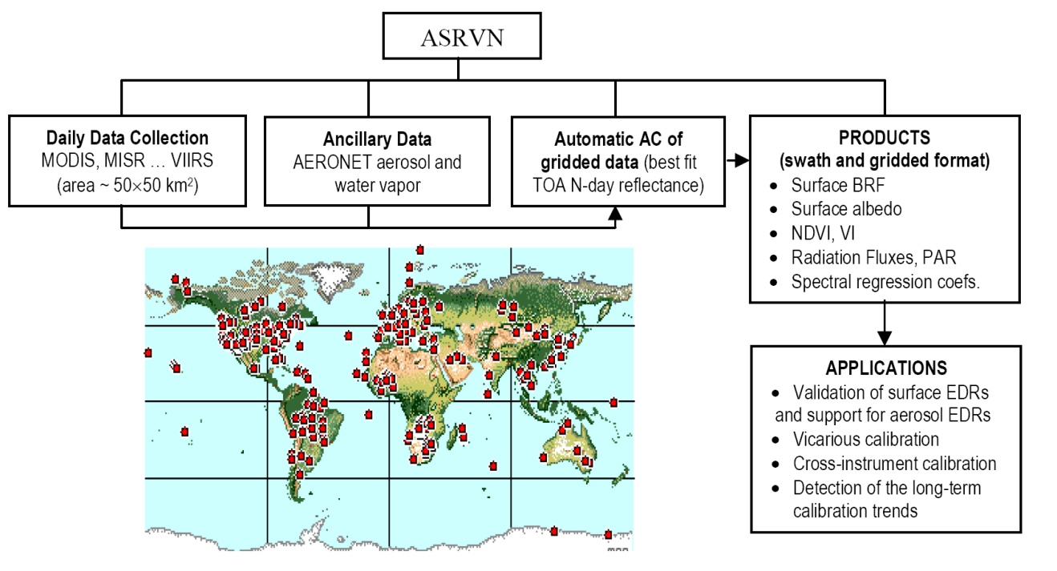

Figure 1. Functional Diagram of AERONET-based Surface Reflectance Validation Network (ASRVN).

Examples of ASRVN products are presented in Figures 2-4. Figure 2 shows a multi-year time series of NBRF for a single pixel. The left panel shows a medium greenness pixel of GSFC (Greenbelt, MD, USA) site, and right panel shows a bright desert pixel of Solar Village (Saudi Arabia). With geometry variations removed, the seasonal variability of NBRF is closely related to vegetation phenology and/or precipitation. Figure 3 shows a time series of NDVI for a vegetated pixel at GSFC site. The NDVI was produced independently using ASRVN spectral NBRF, albedo, and surface reflectance (IBRF). The latter is equivalent to the top-of-canopy NDVI, as well as the IBRF is fully equivalent of the surface reflectance IP. For comparison, Figure 3 also shows the top-of-atmosphere (TOA) NDVI (black crosses), which has a high noise and lower values than the atmospherically corrected NDVI.

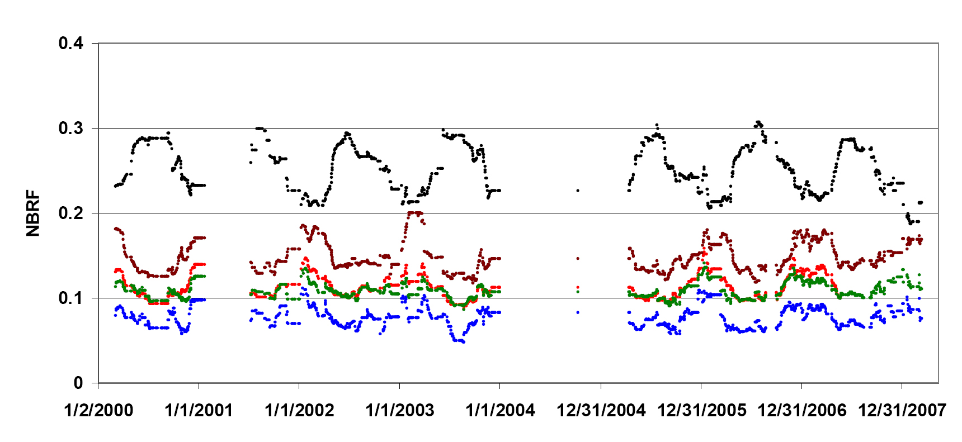
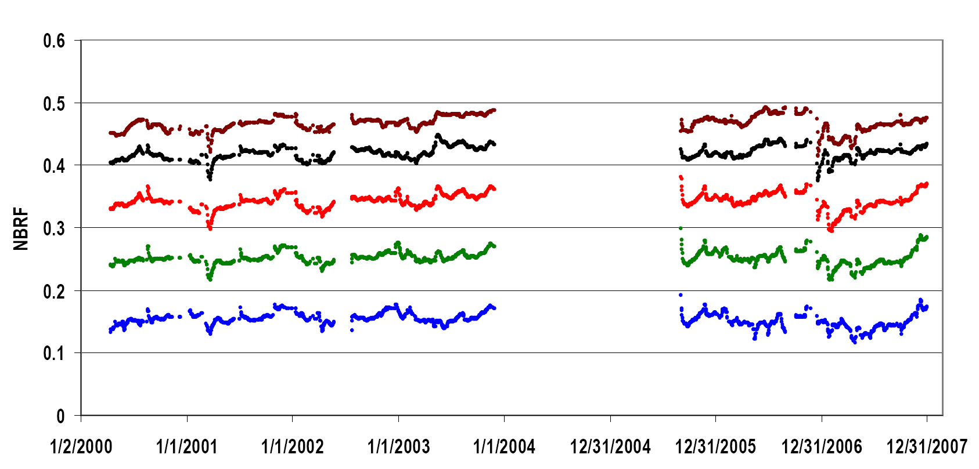
a
b

Figure 2. NBRF time series for a medium greenness pixel, GSFC site (a) and for a bright desert pixel, Solar Village (b). Red, green and blue colors represent respective MODIS bands; black is near infrared (NIR) band and brown is band 7 (2.1m).

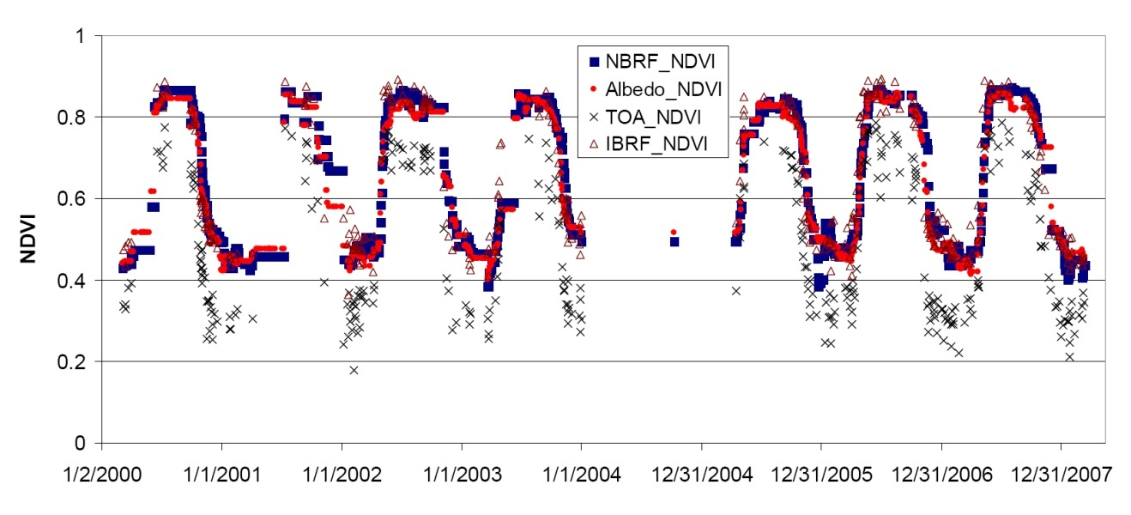

Figure 3. NDVI time series of a vegetated pixel for GSFC site.
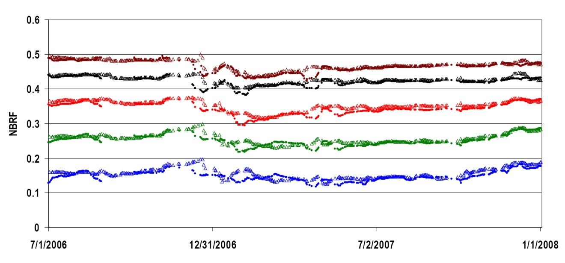

Figure 4. Comparison of MODIS Terra and Aqua NBRF for a bright pixel (Solar Village). Here, triangles and solid circles represent Aqua and Terra NBRF, respectively. Red, green and blue bands are shown with their respective color, black shows NIR band and brown corresponds to band 7 (2.1m).

These examples show a very good inter-annual reproducibility and low noise of ASRVN surface reflectance products. Because AERONET data are well calibrated, analysis of the ASRVN NBRF time series will help detection the VIIRS long-term calibration trend. On the other hand, comparison of NBRF records produced from different VIIRS instruments will help sensor cross-calibration. As an example, Figure 4 illustrates an initial comparison of ASRVN NBRF independently produced from MODIS Terra and Aqua.
Special attention will be placed on validation of surface reflectances over water surfaces and snow surfaces, where current weaknesses in atmosphere corrections result in large impacts on vegetation indices. This is problematic along coastal areas, wetlands and riparian zones, areas that periodically flood, and large expanses at high latitudes with snow/ice and snow melting mixing with vegetation green-up. There are several AERONET sites located in proximity to large lakes and in areas that have seasonal snowfall.
Currently developed for MODIS, the ASRVN processing will be adjusted for the VIIRS data stream. This activity will require sub-setting capabilities from the VIIRS L1B operational processing and subset data storage at GRAVITE (or ASRVN server). Similarly to MODIS, the VIIRS subsets can be used for an in-depth local scale algorithm analysis and validation for aerosol retrievals and cloud mask.
Because the ASRVN-based approach may not independently capture certain sensor based problems, upstream of the level 1B data (e.g., filter degradation), we will complement our validation and analyses will be complemented with independent ground-based data from the Baseline Surface Radiation Network (BSRN) radiometers. Preliminarily, BSRN measurements will be atmospherically corrected to remove diffuse sky irradiance. Using the Boston University method described above, ground-based BSRN measurements will be selected from sites with high degree of surface homogeneity at a scale comparable to satellite footprint. Many of the BSRN tower sites also provide broadband albedo VI’s useful in validation with appropriate broadband- narrowband conversions. BSRN comparisons with ASVRN reflectance/VI’s will be facilitated with the Satellite Product Evaluation Center (SPEC) tool, a prototype of which was developed in 2007 in a joint endeavor between NOAA’s NCDC and the ORNL DAAC. An advanced version of SPEC, which will work with parameters from all disciplines (ocean, atmosphere, etc.), provide cloud detection, and operate in both interactive and “background/anomaly detection” mode, is currently in development. With increasing frequency, the BSRN tower network is providing PAR (photosynthetically-active radiation) data sets that can be used to derive fAPAR (fraction of absorbed photosynthetically-active radiation), useful in validation of the vegetation indices across seasons and land cover types.

Additionally, SPEC will provide readily available and continuous (daily) measures of biologic vegetation activity (gross primary productivity, GPP) through an existing and rapidly growing global network of eddy covariance flux tower sites, FLUXNET. The SPEC tool will ensure seasonal- phenologic/ biologic consistencies between VI’s and independent biologic measures and further enable cross-sensor comparisons of VIs and reflectances to an independent biologic surface variable, such as canopy photosynthesis (Gross Primary Productivity). A good test of biologic consistency between VIIRS and heritage sensors is the extent to which seasonal and interannual VI-biophysical relationships are sensor-independent. Another test for the NASA climate data record goal is to assess the extent and sensitivity to which VIIRS reflectances and VIs are able to detect “climate signals”, such as inter-annual drought events and weaker signals due to shifting patterns in biome seasonality.

Together, ASRVN and BSRN will provide a continuous stream of validation support throughout the lifetime of the VIIRS instruments thus addressing the issue of the time series accuracies and of the long term stability of EDRs. Further, ASRVN will provide an immediate post-launch global analysis of the on-orbit instrument and algorithm performance by comparing the new ASRVN surface reflectance record from NPP VIIRS with an existing ASRVN records from MODIS. We plan to concentrate our cross-sensor validation efforts beyond correlative comparisons of the derived products and critically analyze sensor-dependent discrepancies and their geographic and temporal patterns. This validation plan’s dependence on existing and sustained measurements collected by external programs allows sustained validation information in a more cost-effective manner relative to episodic field campaigns. Further, the tools, resources and expertise that will be employed for VIIRS Surface Reflectance and Vegetation Index validation leverage EOS investments, as well as tools developed for VIIRS LST and Albedo validation (e.g., SPEC).

Holben, B. N., T. F. Eck, I. Slutsker, D. Tanré, J. P. Buis, A. Setzer, E. Vermote, J. A. Reagan, Y. J. Kaufman, T. Nakajima , F. Lavenu, I. Jankowiak, A. Smirnov, AERONET-A Federated Instrument Network and Data Archive for Aerosol Characterization, Rem. Sens. Environ., 66, 1-16, 1998.
Huete, A.R., Huemmrich, K.F., Miura, T., Xiao, X., Didan, K., Leeuwen, W., Hall, F., Tucker, C.J., 2006, Vegetation Index greenness global data set: White Paper for NASA ESDR/CDR <http://lcluc.umd.edu/Documents/land-esdr.asp>
Lyapustin, A., Y. Wang, and R. Frey, “An Automatic Cloud Mask Algorithm Based on Time Series of MODIS Measurements”, J. Geophys. Res., 113, D16207, doi:10.1029/2007JD009641, 2007.
Schaaf, C. B., F. Gao, A. H. Strahler, W. Lucht, X. Li, T. Tsang, N. C. Strugnell, X. Zhang, Y. Jin, J.-P. Muller, P. Lewis, M. Barnsley, P. Hobson, M. Disney, G. Roberts, M. Dunderdale, C. Doll, R. d'Entremont, B. Hu, S. Liang, and J. L. Privette, First Operational BRDF, Albedo and Nadir Reflectance Products from MODIS, Remote Sens. Environ., 83, 135-148, 2002.
Wang, Y., A. Lyapustin, J. L. Privette, J. T. Morisette, Brent Holben, ”Atmospheric Correction at AERONET Locations: A New Science and Validation Data Set,” IEEE TGARS, 2009 (in press).

Milestones Toward Exit Criteria

We will conduct the following work to prototype VIIRS-applied methods and prepare for NPOESS:
- Extend ASRVN algorithm to produce surface reflectance (IBRF), NDVI IP and EVI at pixel resolution in swath format (currently produced in gridded 1 km format) for direct comparison.
- Finalize and validate ASRVN processing over snow and water.
- Prototype validation analysis of MODIS surface reflectance, NDVI IP and EVI.
- In collaboration with VIIRS aerosol validation activities (Dr. I. Laszlo), study an accuracy of spectral regression coefficient as a function of landcover type, seasons, and view geometry.
Prelaunch
- Adapt ASRVN codes to work with VIIRS
- Develop ASRVN-VIIRS EVI and BRF
- Evaluate ASRVN-VIIRS performance with Proxy VIIRS Data
- Develop operational ingest and processing codes for BSRN and Fluxnet data
- Develop BSRN-based spectral reflectance product and feasibility of BSRN-based VI product.
- Evaluate BSRN reflectance performance with Proxy VIIRS Data
- Evaluate Fluxnet –derived biophysical measures with Proxy VIIRS Data

Postlaunch
- Commence systematic near-real-time evaluation of Surface Reflectance, NDVI IP and EVI
- Stratify product accuracies by Surface Type, seasonal- phenology, and seasonal aerosol patterns
- Perform complex analysis of all error sources (including cloud mask and aerosol retrieval) in VIIRS Surface Reflectance and Vegetation Indices, including snow- and water-related error sources.
- Assess operational viability, through statistical representations of the frequency of acceptable pixel samplings in time and space.
- Help Tune Cloud Mask, AOT and Surface Reflectance Algorithms by Surface Type using ASRVN-based results (for areas where these algorithms are underperforming)
- In conjunction with the NASA Land PEATE conduct assessments of the usefulness of VIIRS reflectances and VIs for NASA’s climate research needs.

Time Required to Perform Activities

We have defined a 5-year development and implementation plan that will allow us to demonstrate and prove a globally valid approach using VIIRS proxy data, then conduct near real time VIIRS EDR validation during the NPP Intensive Cal/Val period. After the Intensive period, we plan to execute a significantly lower cost “maintenance validation” and long term trending phase that leverages the early investments and developments.

Bibliography

Vermote, E. and Kotchenova, S. (2008), Atmospheric correction for the monitoring of land surfaces, J. Geo. Res., 113, D23S90.

Sharma, A. R. Badarinath, K. V. S. and Roy, P. S (2009), Comparison of ground reflectance measurement with satellite derived atmospherically corrected reflectance: A case study, Advances in Space Research, 43, pp 56-64.

Return to Product List

Cryosphere Products: Snow Cover and Depth

Validation Drivers
VIIRS data will be used to generate several unique products within the Snow Cover/Depth EDR, including a binary snow/no snow mask and a snow cover fraction estimate. A snow depth estimate is not required from VIIRS. Although MODIS provides a binary snow mask, it does not have the fractional cover as a standard product, and therefore the VIIRS validation approach will require some new developments.
This validation plan’s dependence on existing and sustained measurements collected by external programs allows sustained validation information in a more cost-effective manner relative to episodic field or aircraft campaigns. Further, the tools, resources and expertise that will be employed for VIIRS Snow Cover/Depth validation leverage EOS, POES and GOES investments. For the Binary Snow Cover Mask, this approach is proven, low cost and should be sustainable throughout the entire NPOESS era. The adjustments to the existing approach to handle the Snow Cover Fraction product should be proven and operational in time for NPOESS C1 launch.

Exit Criteria
Successful initial validation is achieved when algorithm performance and product accuracy are credibly characterized across the whole variety of Earth’s physio-geographical conditions, climate conditions and satellite observation conditions. With respect to the geographical coverage, this means evaluation of the product accuracy over all continents (including the Southern Hemisphere) and over all major land surface types and vegetation cover types within each continent. As a minimal requirement, the products should be evaluated daily and the evaluation period should cover at least one whole year of observations. Because of a possible year-to-year variation in climatic conditions and corresponding variability in the seasonal snow cover distribution, a justified conclusion on the algorithm performance should be based on the results of two to three years of continuous assessment of derived snow cover maps.

Activities Required to Meet Exit Criteria
This plan provides an assessment of VIIRS snow cover maps over all continents. The primary focus will be on areas affected by seasonal snow. The analysis will include all major land surface types and vegetation cover types: deserts, grasslands/croplands, deciduous and coniferous forests, tundra, urban areas, and mountains. For forested areas, the accuracy estimates will be stratified with respect to the density of forest cover. We will specifically concentrate on surface cover types that can be easily confused with snow, such as dry salt lakes and sandy beaches. Since many snow detection errors are caused by misinterpretation of clouds or cloud shadows, we will thoroughly examine areas covered with dense clouds and pixels located next to cloudy pixels.

The validation strategy will closely follow the approach used to evaluate the accuracy of current operational automated snow products at NOAA/NESDIS (Romanov et al., 2000, 2002). It includes (1) the comparison of satellite-based snow cover maps with snow depth reports from ground-based stations, (2) comparison of automated snow maps with snow and ice charts generated interactively within NOAA Interactive Multisensor Snow and Ice Mapping System (IMS), and (3) visual inspection and comparison of satellite-derived products with original satellite imagery in different spectral bands.

Validation of VIIRS daily snow cover products will be performed only over cloud-free portions of the imagery. The approach includes two stages of validation, the primary and the secondary. The primary validation will be performed each day after product generation. It will utilize in-situ data that arrived within the prior 24 hour time period as well as the previous day’s IMS product over the Northern Hemisphere. Both products will be used to assess the accuracy of the VIIRS-based snow cover map. The secondary, more accurate and detailed validation, will be performed with a delay of one to several months after VIIRS product generation. It will involve all available in-situ data for that day, including those data that were not available at the time of the primary validation. The secondary validation will also include visual inspection and analysis of derived snow maps and the original satellite imagery. The focus of the visual inspection will be on the areas where independent data on snow cover are unavailable or sparse. The comparison of VIIRS snow cover maps with in-situ data and with IMS maps will result in a quantitative characterization of the snow map accuracy. The results of the visual inspection of satellite imagery will provide only qualitative evaluation of the algorithm’s ability to adequately reproduce the snow cover distribution in various conditions over specific geographic areas. Brief details on the data and techniques to be used are given below.

Comparison with in situ data

Operational daily reports of the depth of snow on the ground will be collected from first-order (WMO) meteorological stations and from US Cooperative Network Stations. Few stations report snow depth in South America (in Argentina and Chile). All other reports come from stations located in the Northern Hemisphere. The number of daily reports of snow depth varies with season and depends on the areal extent of the snow cover. In the peak of the Northern Hemisphere winter season, NOAA/NESDIS typically receives about 1500 valid daily snow depth reports. These are used in the operational validation of NESDIS automated snow map products. For example, Figure 1 shows a snow map derived from NOAA AVHRR with surface observations overlaid.

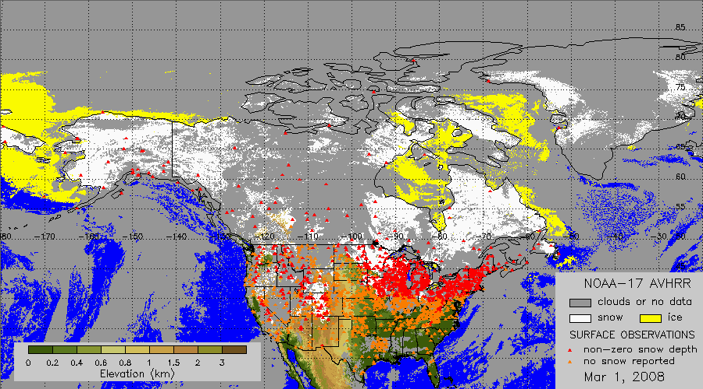
Fig.1 NOAA-17 AVHRR daily snow map with surface observations overlaid. Red/orange triangles show stations reporting snow/no snow on the ground.

Another source of in situ data are Canadian Climate stations. Daily observations of snow depth are available from about 300 such stations; however the results are compiled and available only on a monthly basis. Therefore, these data will be used in the secondary validation of VIIRS snow products. The secondary validation will also include WMO station data, which arrived outside the 24-hour window, and therefore are not used in the primary snow map validation.

Validation of VIIRS snow map will be performed by matching classified image pixel data with in situ snow depth measurements. As a quantitative measure of Probability of Correct Typing (PCT), as defined by the NPOESS System Specification for the accuracy of the daily map, we will use the percent of “hits” in the total number of comparisons. “Hits” include cases when surface observation and satellite classification result agree on snow or snow free land surface (no snow).

In the current approach, we assume that the image navigation error does not exceed one image pixel. If the latter is not true, satellite-surface match-ups will include blocks of 3x3 image pixels. In this case, pixel blocks containing mixed classification results will be excluded from the analysis.

The snow map accuracy analysis will account for the snow cover climatology. Separate statistics on the correspondence between the VIIRS product and surface observation data will be generated for the whole area as well as for the area that excludes regions that are consistently snow covered and consistently snow free at the time of observation.

Comparison with IMS data
Interactive snow and ice charts are generated at NOAA on a daily basis. Maps cover the Northern Hemisphere at a spatial resolution of about 4 km (see Helfrich et al., 2006 and Ramsay, 1998). NOAA plans to increase the spatial resolution of the maps to 1 km in the near future. VIIRS-IMS comparisons will be performed over the Northern Hemisphere through a straight-forward matching of corresponding pixel data in both maps. Only cloud-free observations in the VIIRS map will be used. The daily statistics will include the fraction of “hits” and “misses”. “Misses” will be split into snow commission and omission errors. In addition to the statistics of correspondence between the two maps, we will also generate a color-coded image presenting IMS data overlaid over the VIIRS snow map (figure 2).
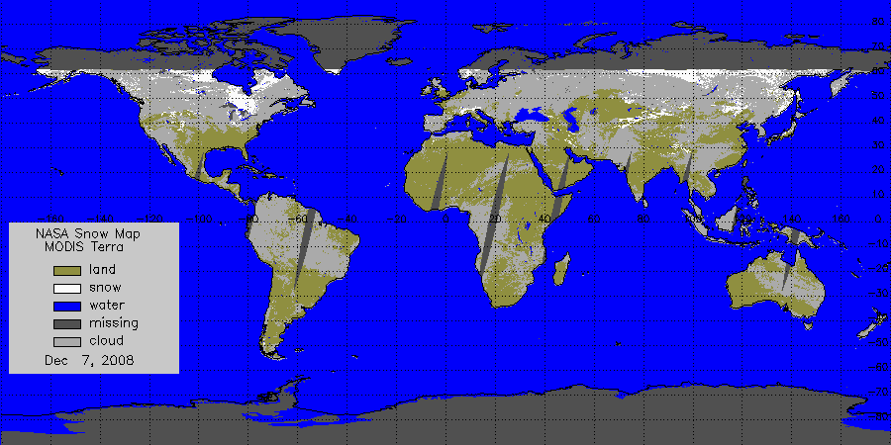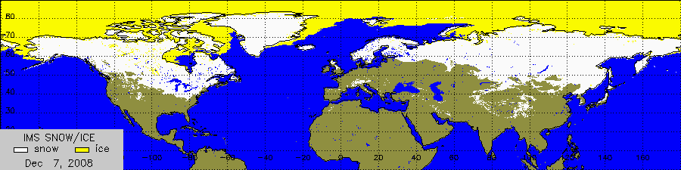
Fig.2 MODIS-Terra snow map at 5 km resolution and corresponding IMS snow/ice chart for Dec 7, 2008.

We will assess the accuracy of estimating the aerial extent of the snow cover. This will be performed by comparing the snow extent in cloud clear pixels of the VIIRS snow map with snow extent derived from corresponding pixels in the IMS snow chart. This will provide an estimate of the probability of correct typing.

Interactive analysis of VIIRS snow maps
Quantitative assessment of the accuracy of VIIRS snow maps through their direct comparison with independent snow cover datasets can be performed only over the Northern Hemisphere. Snow cover is not mapped interactively over the Southern Hemisphere and snow depth reports are occasionally available from a few stations in South America. Therefore the only way to evaluate the algorithm performance in the Southern Hemisphere consists in the visual examination of derived snow cover maps and corresponding satellite imagery. The same approach will also be applied in high latitude areas of the Northern Hemisphere where the network of ground-based stations is very sparse.

Interactive evaluation of product accuracy will be conducted on a case-by case basis. Depending on the resources available, the qualitative assessment of the accuracy will be performed at time intervals from one week to one month. The focus of this work will be on obvious failures of the algorithm to properly identify snow and on false identification of snow cover. As time and resources allow, we will attempt to identify the root cause of algorithm problems in cooperation with the NPOESS Prime Contractor. The results will be presented in the form of short snow map quality assessment reports.

All reports will be summarized on a yearly basis to identify possible persistent problems in VIIRS snow cover mapping.

Snow Cover Fraction

Currently, the coarser resolution VIIRS Snow Cover Fraction is produced as a simple addition of “positive snow” values within a 2 x 2 kernel of the VIIRS Binary Snow Cover Mask. Therefore, the validation approaches above will, to some extent, provide validation information on the Snow Cover Fraction product. However, even if the Binary Map is error-free, its validation is not sufficient for the Cover Fraction product since each cell in the Binary Snow Cover Map is actually depicting ground surface area, which may only be partially snow covered. The VIIRS snow cover fraction product currently has no equivalent in the current NOAA NESDIS snow validation framework, however validation work a similar EOS MODIS product demonstrates credible results using snow-classified imagery from fine resolution aircraft (e.g., MAS, MASTER-like) and satellite (e.g., Landsat, SPOT, IKONOS, QuickBird) systems. Therefore, we will budget for time and resources to collect and analyze fine resolution imagery during the NPP Intensive Calibration/Validation Period. Following that period, we will conduct less frequent but regular validation checks using the same approach to ensure the combined sensor and algorithm system continues to produce credible results. We will continue to work with and monitor progress and approaches on automated snow cover classification of fine resolution imagery.

Impact

At NOAA and the Department of Defense, accurate information on the snow cover distribution is needed in numerical weather prediction, hydrological modeling and climate change studies. The modeling community uses accuracy information alongside product data for assimilation purposes, among other uses. Information on snow cover distribution as well as on the accuracy of mapped snow is also important for analysts at the NOAA National Ice Center (NIC), who will be using VIIRS automated snow maps to generate interactive snow cover maps within the IMS system. During the project implementation, we will work closely with NOAA National Centers for Environmental Prediction (NCEP), Climate Prediction Center (CPC), Office of Hydrologic Development and National Ice Center (NIC) to ensure that information on the snow map accuracy satisfies their needs.

Milestones Toward Exit Criteria

To achieve the above vision during the NPP era, the following developments must be pursued and implemented in the NPP prelaunch and early post-launch period. The tasks and level of effort are organized as a 5-year effort, based on the assumption that the general mission timeline is as follows. 2009-mid 2011: Prelaunch period (assumes 30-90 early on-orbit check out); late 2011-early 2013: Intensive Cal/Val (ICV) period; mid-2013 - 2014: Long-Term Monitoring (LTM) period. The project years listed below assume a mid-year initiation of funding (i.e., effort begins in June 2009, so each project year spans one calendar year).
Risks
The risks associated with the use of surface observation data and IMS snow charts to validate VIIRS snow product are minimal. All products to be used are generated at NOAA operationally and any disruption to their availability is unlikely.

Year 1 (2009 – 2010)

- Develop algorithms and codes to acquire simulated VIIRS data from NPP-Land PEATE
- Develop algorithms and corresponding software to acquire operationally available observations of snow depth from first-order (WMO) and US Cooperative network stations.
- Develop of algorithms and software to match snow retrievals from VIIRS with surface observation data and to generate the statistics of comparison.
Resource Requirements: 0.6 FTE research scientist/computer programmer, travel expenses to attend VIIRS team meetings and AGU meeting and 1 TB disk storage

Year 2 (2010-2011)

- Test validation algorithms with simulated VIIRS data.
- Refine the primary (operational) validation strategy.
- Develop software to acquire and process in-situ data for secondary validation
- Modify and improve system to acquire surface observation data both for primary and secondary validation.
- Develop of algorithms and software to match VIIRS snow retrievals with IMS snow/ice charts and to calculate the statistics of comparisons
- Test algorithms and software with proxy VIIRS data and MODIS retrievals
- Demonstrate the system operation.
- Document the codes and algorithms
- Prepare the developed software for operational implementation.
Resource Requirements: 0.65 FTE research scientist/computer programmer, travel expenses to attend VIIRS team meetings and AGU meeting

Year 3 (2011-2012)
- Continue testing algorithms for the primary and secondary snow map validation
- Immediate post-launch production of quality assessment data.
- Evaluate performance of the snow map quality assessment system
- Modify and tune the system as necessary.
- First results from the primary snow cover product validation will be obtained
Resource Requirements: 0.65 FTE research scientist/computer programmer, travel expenses to attend VIIRS team meetings and initial publication costs

Year 4 (2012-2013)
- Collect data for secondary snow cover map validation.
- Modify and improve data collection algorithms if necessary
- Continue routine evaluation of snow map accuracy
- Support routine operation of the quality assessment system.
- Start routine interactive analysis of the snow map accuracy
Resource Requirements: 0.65 FTE research scientist/computer programmer, travel expenses to attend VIIRS team meetings and AMS Meeting

Year 5 (2013-2014)
- Continue routine quantitative and qualitative evaluation of VIIRS snow map accuracy
- Generate quarterly reports on the algorithm performance and accuracy of the product
- Provide routine support for operations and maintenance of the quality assessment system
- Continue routine interactive analysis of the snow map accuracy
- Modify all algorithms and software to provide validation of C1 VIIRS snowmap data.
Resource Requirements: 0.65 FTE research scientist/computer programmer, travel expenses to attend VIIRS team meetings and AMS Meeting

Time Required to Perform Activities

We have defined a 5-year development and implementation plan that will allow us to demonstrate and prove a globally valid approach using VIIRS proxy data, then conduct near real time VIIRS EDR validation during the NPP Intensive Cal/Val period. After the Intensive period, we plan to execute a significantly lower cost “maintenance validation” and long-term trending phase that leverages the early investments and developments.

References

Ramsay, B. (1998). The interactive multisensor snow and ice mapping system, Hydrological Processes, 12, 1537-1546.

Romanov, P., G. Gutman, and I. Csiszar (2000) Automated monitoring of snow cover over North America with multispectral satellite data, Journal of Applied Meteorology, 39, 1866-1880

Romanov, P., G. Gutman and I. Csiszar, 2002: Satellite-derived snow cover maps for North America: accuracy assessment. Advances in Space Research, 30, 2455-2460.

Helfrich S.R., D. McNamara, B. H. Ramsay, T. Baldwin and T. Kasheta (2006) Enhancements to, and forthcoming developments in the Interactive Multisensor Snow and Ice Mapping System (IMS), Hydrological Processes, 21, 1576–1586.

Return to Product List

Cryosphere Products: Ice Surface Temperature and Sea Ice Characterization

Validation Drivers

Presently, there are many cryosphere satellite products with well-established user communities and stakeholders. The VIIRS products that are critical for the continuation of existing cryosphere operational data fields and climate records include:

- Ice Surface Temperature (IST)
- Surface Albedo EDR (includes albedo over snow/ice), and
- Ice Concentration Intermediate Product (IP).

Note that the Ice Concentration IP is not an NPOESS deliverable product. However, the accuracy of the IP affects other sea ice EDRs and is fundamental to their generation. Ice concentration is also a product with considerable heritage and utility for operational and research users. NOAA’s NCDC is developing plans to archive this Retained IP. Thus, the Team will address its validation.). Note also that surface albedo over snow/ice is another parameter requiring dedicated validation. However, it is included in the Surface Albedo EDR and is not a standalone product.

These products are currently available from AVHRR and MODIS, are produced operationally, and are not dependent upon the availability of passive microwave data (from the future MIS, for example). As these products are derived primarily from visible/near-infrared imagery, they can and should achieve high performance – and meet specifications -- with NPP.

Ice age, which is related to thickness, is a critical parameter in the energy budget and will play an important role in numerical weather prediction in the future. Currently there is no established ice age product from AVHRR or MODIS although research-grade products derived from AVHRR have recently been developed and provide a useful proxy for VIIRS

Below we outline two levels of calibration/validation activities: 1) a low cost “Product Verification and Initial Validation” approach which primarily includes comparisons against existing satellite products, and 2) a “Comprehensive Validation” approach which includes all aspects of (1), plus dedicated VIIRS cryosphere product activities executed in cooperation with externally-funded cryosphere research campaigns. Both approaches emphasize cost effectiveness as appropriate for an operational program. Specifically, we will leverage expertise and resources developed during the EOS era, and build upon a previously-funded IPO IGS VIIRS snow and ice risk reduction project (PI: J. Key), a current NASA NPP Science Team activity (PI: J. Maslanik) and a GOES-R Advanced Baseline Imager (ABI) snow and ice product development project (PI: J. Key).

The overall strategy follows the approaches used previously for cal/val efforts associated with AVHRR and MODIS cryosphere products. Details describing approaches used by the Land Team investigators that involved algorithm validation and relevant data collection and assembly methods are provided in Curry et al. (2004), Emery et al. (1994a, 1994b), Fowler et al. (2003), Haggerty et al. (2002), Key and Haefliger (1992), Key and Collins (1997), Key et al. (1994, 1997), Maslanik et al. (2001, 2002; 2006), Meier et al. (1997), Riggs et al. (1997), Stroeve et al. (2001), and Wang and Key (2005a, 2005b).

Activities Required to Meet Exit Criteria

Product Verification and Initial Validation
This intermediate-level cal/val strategy primarily involves direct comparisons of VIIRS IST, albedo, ice concentration, and ice age with their AVHRR and MODIS analogs. The goals are (1) an assessment of product accuracy and EDR continuity through statistical analysis and direct comparisons with existing products, and (2) an examination of improvements to VIIRS algorithm parameterizations, look-up table, and other algorithm dependencies. These activities also pertain to the NPOESS operational products produced by the IDPS. This will not entail any basic algorithm changes but instead would address algorithm requirements that are already built into the existing code. Digital data products will be used extensively, including, but not limited to, high-resolution satellite data (e.g., Landsat) and the Interactive Multisensor Snow and Ice Mapping System (IMS), National Ice Center and Canadian Ice Service ice charts and passive microwave- and radar-derived products for ice concentration, and AVHRR/MODIS products for IST, albedo, and ice concentration. Figure 1 gives and example of comparing ice concentration derived from two methods with MODIS to passive microwave-derived concentration. Figure 2 is an example of ice thickness and “age” (type) from AVHRR. Figure 3 gives a comparison of ice thickness distributions from three sources. The work will also employ any available information from aircraft or field operations of opportunity conducted by other agencies.
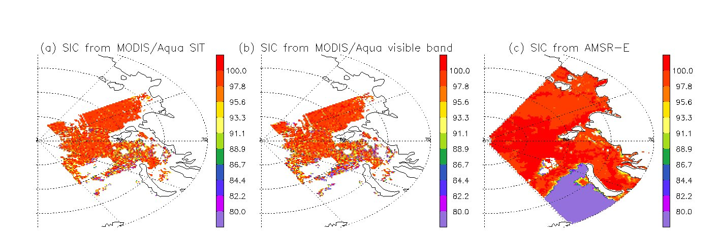
Fig. 1. Sea ice concentration (SIC) (%) retrieved from (a) MODIS Sea Ice Temperature (SIT), (b) MODIS visible band reflectance, and (c) from Advanced Microwave Scanning Radiometer - Earth Observing System (AMSR-E) Level-3 gridded daily mean from NSIDC on March 31, 2006.

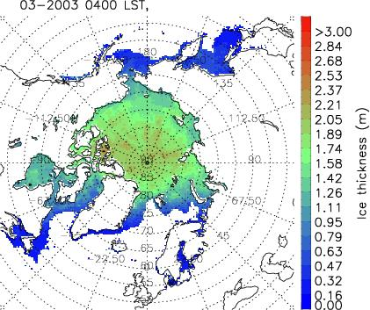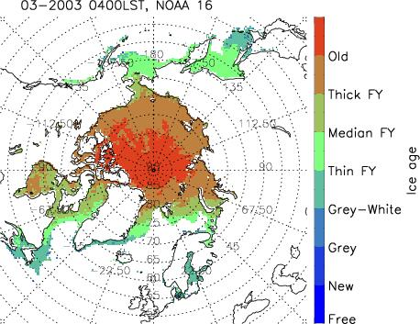
Fig. 2. Monthly mean ice thickness (left) and ice age (right) based on the AVHRR Polar Pathfinder-extended (APP-x) product for March 2003 under all sky conditions.
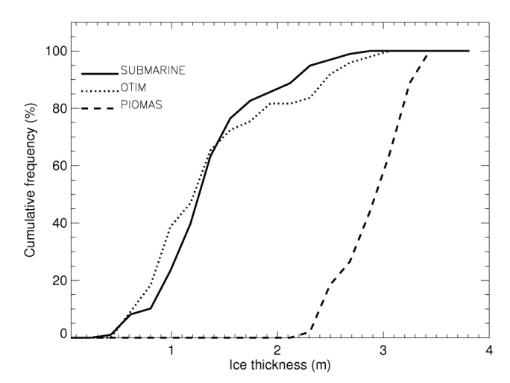
Fig. 3. Comparison of the cumulative ice thickness distribution estimated from APP-x data (“OTIM”), submarine sonar measurements, and simulated by the Pan-Arctic Ice-Ocean Modeling and Assimilation System (PIOMAS) model (U. Washington) over the Arctic.

Comprehensive Validation
Given the historic changes and importance of the cryosphere, and the economic and defense implications of recent sea ice changes (e.g., seasonal opening of the Northwest Passage), we strongly prefer a more extensive cal/val effort that would be fully scientifically defensible. The intermediate-level cal/val steps outlined above would be augmented with dedicated data collection specific to VIIRS cal/val needs. The goal is to not only assess the overall quality of the VIIRS cryospheric products, but to also determine and quantify the most likely sources of error affecting the algorithms. To maximize cost sharing, we would use NPOESS validation funding to augment other planned field projects of opportunity such as aircraft missions and field data collection efforts funded by NASA, NSF, NOAA, and other agencies such as the Minerals Management Service that are currently engaged in sea ice monitoring. The augmentation would support the involvement of VIIRS cal/val scientists and to allow for the inclusion of specific sensors and/or measurement strategies to address VIIRS needs that might not otherwise be adequately addressed. For example, a continuously-calibrated skin temperature sensor could be added to NASA P-3 flights and/or U.S. Coast Guard Arctic Domain Awareness flights for VIIRS IST validation, or a spectrometer could be added to assist with ice albedo validation as part of NASA-funded unmanned aerial vehicle (UAV) flights designed for Cryosat-II validation, or an additional field participant might be added to an NSF-funded ice thickness mapping project to collect in-situ skin temperatures. Augmenting such field campaigns of opportunity, such as was done to make AMSR validation more useful for MODIS and AVHRR comparisons (Figure 4; Maslanik et al., 2006), is a cost-effective way of obtaining data particularly relevant to VIIRS. In a similar way, existing networks such as ARM sites and GC-Net can help serve as inexpensive long-term monitoring sites that would be used to identify sensor drift and degradation in algorithm performance.

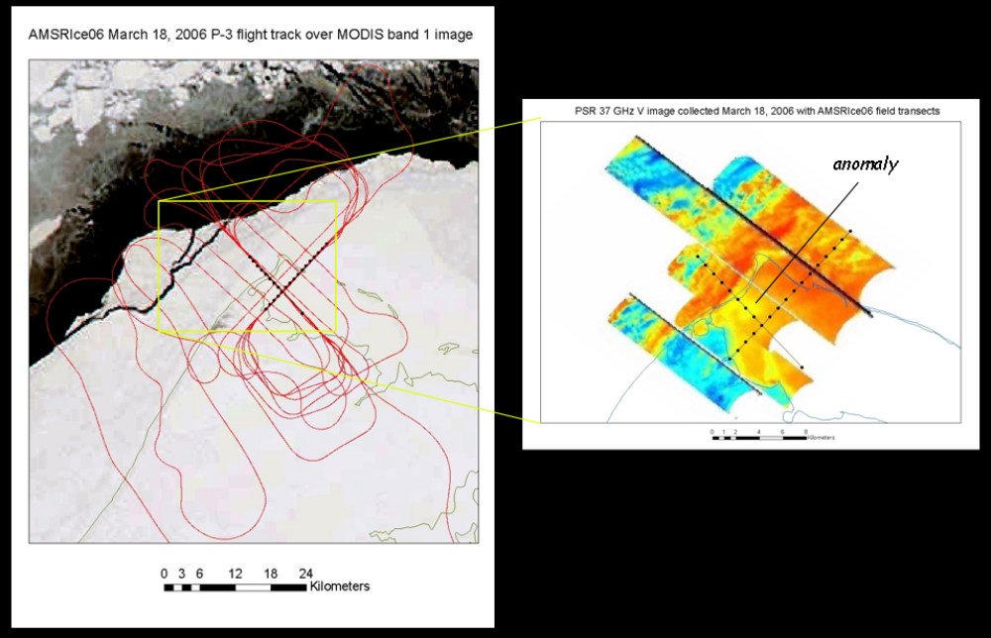
Fig. 4. Combinations of low- and medium-altitude aircraft flights with in-situ measurements during the AMSRIce06 field campaign near Barrow, Alaska. Aerial photography and laser profiling acquired by the aircraft are directly relevant to validating cryospheric products derived from visible- and thermal-band imagery.

The comparisons will be facilitated with the Satellite Product Evaluation Center (SPEC) tool, a prototype of which was developed in 2007 in a joint endeavor between NOAA’s NCDC and the ORNL DAAC. An advanced version of SPEC, which will work with parameters from all disciplines (ocean, atmosphere, etc.), provide cloud detection, and operate in both interactive and “background/anomaly detection” mode, is currently in development.

This validation plan’s dependence on existing and sustained measurements collected by external programs allows sustained validation information in a more cost-effective manner relative to episodic field or aircraft campaigns. Further, the tools, resources and expertise that will be employed for VIIRS IST and Sea Ice Characterization validation leverage EOS and GOES-R investments, as well as tools developed for elsewhere in this plan.

Milestones Toward Exit Criteria

To achieve the above vision during the NPP era, the following developments must be pursued and implemented in the NPP prelaunch and early post-launch period. The period up until 6 months prior to launch will be devoted to developing and testing methods (as automated as possible) using AVHRR and MODIS (Aqua and Terra) products as VIIRS proxies, and other satellite and in situ data for validation. This will establish a productive and efficient validation system. The tasks and level of effort are organized as a 5-year effort, based on the assumption that the general mission timeline is as follows: 2009 through mid-2011 - Prelaunch period (assumes 30-90 early on-orbit check out); late 2011 through early 2013 - Intensive Cal/Val (ICV) period; mid-2013 through 2014 - Long-Term Monitoring (LTM) period. The project years listed below assume a mid-year initiation of funding (i.e., effort begins in June 2009, so each project year spans one calendar year).

Year 1 (2009 – 2010; Prelaunch period)
- Generate test plan outlining major testing milestones for Years 1 – 5.
- Develop a data inventory, sampling strategy, data acquisition, ingest, collocation for case studies
- Develop software to match ice retrievals with surface observations and other satellite data
- Test algorithms with proxy VIIRS data.
- Generate accuracy statistics.
- Refine the primary (operational) validation strategy.
- Develop algorithms and codes to acquire simulated VIIRS data from NPP-Land PEATE
- Identify and assemble comparison data sets and proxy VIIRS data.
- Identify potential field/aircraft/in-situ projects of opportunity and initiate coordination with project coordinators.
- Refine the primary (operational) validation strategy.
- Generate summary reports, identify test plan milestones achieved, explain any revisions made to the test plan.

Year 2 (2010-2011; Prelaunch period)
- Continue data acquisition, ingest, collocation, statistical analysis.
- Coordinate validation activities with field campaign (airplane) partners for further data collection.
- Develop systematic post-production quality control (QC) procedures.
- Modify and improve the system to acquire surface observation data both for primary and secondary validation.
- Test algorithms and software with proxy VIIRS data and MODIS retrievals
- Test all algorithms and software in real-time mode.
- Demonstrate the system operation.
- Document the code and validation algorithms.
- Prepare the software for operational implementation.
- Modify and improve system to acquire surface observation data both for primary and secondary validation.
- Develop algorithms and software to match VIIRS snow retrievals with IMS snow/ice charts and to calculate the statistics of comparisons
- Test algorithms and software with proxy VIIRS data and MODIS retrievals
- Test all algorithms and software in real-time mode.
- Demonstrate the system operation.
- Document the code and algorithms.
- Prepare the developed software for operational implementation.
- Acquire and test field instrumentation.
- Generate summary reports, identify test plan milestones achieved, explain any revisions made to the test plan.

Year 3 (2011-2012; Intensive Cal/Val period)
- NPP post-launch systematic post-production QA.
- Continue data acquisition, ingest, collocation, statistical analysis, including initial VIIRS data.
- Acquire targeted airborne data.
- Additional validation case studies with new satellite, in situ, and airborne data.
- Immediate post-launch production of quality assessment data.
- Modify and tune the system as necessary.
- Primary sea ice product validation.
- Initial provision of algorithm look-up table input and parameters required by algorithms.
- Assemble satellite data for secondary validation of ice products.
- Coordinate with and participate in field projects of opportunity.
- Prepare reports and manuscripts summarizing post-launch initial performance.
- Generate summary reports, identify test plan milestones achieved, explain any revisions made to the test plan.

Year 4 (2012-2013; Intensive Cal/Val period)
- Continuation of post-launch production of quality assessment data.
- Collect data representing full annual cycle of ice conditions.
- Process field observations, including merging with satellite data for multi-scale validation.
- Complete secondary ice validation.
- Finalize post-launch algorithm operational input, including look-up table and parameter entries.
- Prepare reports and manuscripts summarizing post-launch initial performance.
- Coordinate archival of cal/val data sets and results, including preparation of metadata and documentation.
- Generate summary reports, identify test plan milestones achieved, explain any revisions made to the test plan.

Year 5 (2013-2014; Long-term Monitoring period)
- Initiate long-term cal/val data collection for instrumented and/or locations of stable surface conditions (e.g., ARM sites, central Greenland, South Pole).
- Assess product consistency.
- Finalize data archival.
- Prepare reports and manuscripts summarizing post-launch initial performance.
- Prepare overall project report describing activities for Years 1-5, key findings, and recommendations.
- Prepare report explicitly documenting results for each element of the project test plan.

Throughout the project period we intend to coordinate our efforts with operational agencies that prepare, distribute and/or use satellite-derived cryospheric products. This applies to snow products described in the previous section along with ice products discussed in this section. Principal among these are the Navy-NOAA National Ice Center, National Weather Service, and Canadian Ice Service (sea ice products and forecasts), resource management agencies such as the U.S. Fish and Wildlife Service and NOAA marine mammal and fisheries services (users of a variety of sea ice information, including ice concentration, age and type), and U.S. Geological Survey and U.S. National Resources Conservation Service (snow cover products). A number of state agencies are also important users of snow cover data, and will be consulted throughout the project.

Time Required to Perform Activities

We have defined a 5-year development and implementation plan that will allow us to demonstrate and prove a globally valid approach using VIIRS proxy data, then conduct near real-time VIIRS EDR validation during the NPP Intensive Cal/Val period. Our plan includes increasing effort through post-launch, an intensive period of effort designed to identify basic algorithm performance metrics as quickly as possible after launch, followed by a significantly lower cost “maintenance validation” and LTM phase that leverages the early investments and developments. The annual level of effort, skill level, and budget (including salary, overhead, and travel) for each project year are:

Year 1 (2009): 2 experts at 4 mo./yr. total, plus 6 mo./yr. for one professional research assistant (PRA).

Year 2 (2010): 2 experts at 4 mo./yr. total, plus 3 mo./yr. for one PRA, plus one 0.5 time graduate research assistant (GRA). We will also acquire and test instrument. The inclusion of a GRA in this project year will initiate the student into the cal/val process with the intent that this student will play a larger role post launch, as indicated below.

Year 3 (2011): 2 experts at 5 mo./yr. total, plus 4 mo./yr. for one PRA plus one 0.75 time GRA.
Year 4 (2012): 2 experts at 3.5 mo./yr. total, plus 3 mo./yr. for one professional research assistant, plus 4 mo./yr. for one full-time GRA, plus 2 mo./yr. for data archival/documentation specialist.

Year 5 (2013): 2 experts at 2.5 mo./yr. total, plus 2 mo./yr. for one professional research assistant, plus one full-time time GRA.

NPOESS C1 Activities
With the launch of C1 VIIRS, we intend to focus on a limited cal/val effort that focuses mainly on documenting the consistency between C1 VIIRS products and the earlier VIIRS. This would include testing changes in algorithm coefficients to maximize product consistency, We will build on the more intensive effort described above, which will allow the initial VIIRS products to serve as critical validation data without the need for a full suite of additional cal/val products. A key aspect of quantifying the effects of the transition between instruments will be use of the cal/val site data initiated in Year 5. In the event that the initial VIIRS fails before C1 launch or has significant data quality issues, the C1 VIIRS cal/val effort would need to include tasks similar to those described above.

References

Curry, J.A., J.A. Maslanik, G. Holland, J. Pinto, G. Tyrrell, J. Inoue, 2004. Applications of Aerosondes in the Arctic, Bull. Am. Met. Soc., 85: 1855-1861

Emery, W.J. and C.W. Fowler and J. Maslanik, 1994a. Arctic sea ice concentrations from special sensor microwave imager and advanced very high resolution radiometer satellite data. J. Geopys. Res.99, 18,329-18,342.

Emery, W.J., C.W. Fowler and J. Maslanik, 1994b. Satellite remote sensing of ice motion. Oceanographic Applications of Remote Sensing, CRC Press. pgs 367-379.

Fowler, C., W. Emery and J.A. Maslanik, 2003. Satellite derived arctic sea ice evolution Oct. 1978 to March 2003, Trans. Geosci. and Remote Sensing Letters, Vol. 1, No. 2, 71-74.

Haggerty, J.A., J.A. Maslanik, and J.A. Curry, 2002. Heterogeneity of sea ice surface temperature at SHEBA from aircraft measurements, J. Geophys. Res., 108, C10, 8052, doi:10.1029/2000JC000560.

Key, J.R. and Collins, J.B., 1997. High-latitude surface temperature estimates from thermal satellite data, Remote Sensing of Environment, 61:302-309.

Key, J. and M. Haefliger, 1992. Arctic ice surface temperature retrieval from AVHRR thermal channels," Journal of Geophysical Research, 97:(D5):5885-5893.

Maslanik, J.A., J.R. Key, C.W. Fowler, T. Nguyen, and X.Wang, 2001. Spatial and Temporal Variability of Satellite-derived Cloud and Surface Characteristics during FIRE-ACE. J. Geophys. Res., 106(D14), 15233-15249.

Maslanik, J.A., J. Curry, S. Drobot and G. Holland, 2002. Observations of sea ice using a low-cost unpiloted aerial vehicle, Proc. 16th. IAHR International Symposium on Sea Ice, Int. Assoc. of Hydraulic Engineering and Research, 3, 283-287.

Maslanik, J.A., M. Sturm, M. Belmonte Rivas, A.J. Gasiewski, J.F. Heinrichs, U.C. Herzfeld, J. Holmgren, M. Klein, T. Markus, D.K. Perovich, J.G. Sonntag, J.C. Stroeve, and K. Tape, 2006. Spatial variability of Barrow-area shore-fast ice and relationships to passive microwave emissivity , IEEE Trans. Geosci. and Remote Sens., Vol. 44, No. 11, IGRSD2, ISSN 0196-2892, 3021-3031.

Meier, W.N., J.A. Maslanik, J.R. Key, and C.W. W. Fowler, 1997. Multiparameter AVHRR-derived products for Arctic climate studies, Earth Interactions, Vol. 1.

Riggs, G. A., D. K. Hall, and S. A. Ackerman,1997. Sea ice detection with the Moderate resolution imaging spectroradiometer Airborne Simulator (MAS). Remote Sensing the Environment.

Stroeve, J., J. Box, C. Fowler, T. Haran, and J.R. Key, 2001. Intercomparison Between in situ and AVHRR Polar Pathfinder-derived Surface Albedo over Greenland. Remote Sensing of the Environment, 75(3), 360-374.

Wang, X. and Jeffrey R. Key, 2005, Arctic Surface, Cloud, and Radiation Properties Based on the AVHRR Polar Pathfinder Data Set. Part I: Spatial and Temporal Characteristics, J. Climate, Vol.18, No.14, 2558-2574, 2005.

Wang, X. and Jeffrey R. Key, 2005, Arctic Surface, Cloud, and Radiation Properties Based on the AVHRR Polar Pathfinder Data Set. Part II: Recent Trends, J. Climate, Vol.18, No.14, 2575-2593, 2005.

Return to Product List

Active Fires

Validation Drivers

The products in the Active Fire ARP include active fire detection (i.e. binary fire mask) and fire characterization in the form of Fire Radiative Power (FRP). Active Fire Detection mirrors a MODIS product and there are well-established protocols for validation. However, there is no heritage procedure for VIIRS FRP validation, which requires simultaneous, unsaturated, high-resolution measurements of instantaneous radiative energy for the entire infrared portion of the spectrum. Airborne and Spaceborne instruments are emerging that are capable of providing unsaturated spectral measurements (e.g. the German/DLR BIRD satellite); research is also ongoing to develop algorithms for the conversion of the spectral measurements to FRP. Field- and air (i.e. UAS)-based area and temperature measurements of experimental fires also can be converted to FRP as a validation reference for satellite-based data.
The NPOESS specification calls for the following Active Fire EDR products: Sub-pixel temperature and sub-pixel area of the active fire. The fire-radiated power mentioned above even though desired is not as of revision N of the NPOESS specification document an official NPOESS product. The following Cal/Val plan which focuses on the fire radiated power is assuming direction from the IPO to include this product in the official active fire EDR.

Exit Criteria

The active fire detection product will be considered validated if the following metrics are established in a statistically robust way for the full range of VIIRS observing geometry and environmental conditions:
- Probabilities of fire detection as a function of sub-pixel fire characteristics. Sub-pixel fire characteristics are measured ideally in actual physical variables such as area or fractional area, and temperature; alternatively, as summary statistics of fire pixels from moderate or high-resolution sensors.
- Omission error rates: fraction of clear VIIRS pixels with confirmed fire activity exceeding pre-defined classification thresholds, not flagged as fire.
- Commission error rates: fraction of VIIRS fire pixels with no confirmed, measurable fire activity.

The FRP product will be considered validated if statistical measures of accuracy are established in physical units (i.e. Watts) compared to FRP reference data for the full range of VIIRS observing geometry and environmental conditions.
These two exit criteria make a lot of sense for the VIIRS active fire EDR (assuming FRP is promoted to EDR status).

Activities Required To Meet Exit Criteria

Active fire detection
The proposed VIIRS active fire validation protocol includes procedures for primary validation (i.e. direct validation using simultaneous active fire observations) and secondary validation (verification of burning based on a-posteriori burned area maps; comparison with validated MODIS product).

The protocol for primary, direct active fire validation builds on procedures developed for MODIS (and later adapted to geostationary sensors). These include 1) the simultaneous mapping of the presence and absence of actively burning fire within the entire pixel footprint at a resolution much higher than the MODIS; 2) the determination of detection probabilities as a function of sub-pixel summary statistics of fire pixels; and 3) the determination of omission rates based on the definition of minimum classification threshold for the fires of interest, as well as determination of commission error rates (Morisette et al., 2005a, 2005b, Csiszar et al., 2006, Schroeder et al., 2008).

The MODIS active fire validation activity takes advantage of the unique configuration of having both MODIS and ASTER flying on the Terra satellite, whereby ASTER-derived fire masks are used as reference. Because of the limited pointing capability of ASTER, the validation is restricted to near-nadir observations (+/- 8.55°). This process therefore provides validation statistics for the optimum angular conditions. Additional validation reference data are needed to determine accuracies of off-nadir conditions.

As the NPP and NPOESS platforms will not carry higher resolution (i.e. at least Landsat-class) imagers to provide simultaneous observations, near-simultaneous imagers on alternative platforms will be used. These imagers include:

1. Any compatible imagers from national and international assets that provide near-simultaneous observations within a specific time window (to be determined as part of this work) of the NPP/NPOESS overpass. Key assets are currently being coordinated by the CEOS Land Surface Imaging Constellation, but not in the context of fire validation. This option is most viable for the NPOESS satellites with a mid-morning orbit (C2 and C4).

2. Airborne imagers flown by United States and international partners. US federal agencies, such as the US Forest Service (Firemapper; Hoffman et al., 2003) and NASA (AMS-Wildfire; Ambrosia et al., 2007) have programs to collect airborne imagery during major fire events. Successful experiments to collect imagery during the Terra and Aqua overpasses have been carried out with the WRAP (Wildfire Research and Applications Partnership) team. Partnership with these programs on a cost-sharing basis can ensure the further collection of imagery for validation purposes at relatively low cost.

Secondary, indirect validation of active fire products will be conducted by confirming the location of the burn using multi-temporal high-resolution burned area maps, typically from remote sensing (limitations of the fire perimeter data have been demonstrated by multiple studies). This procedure has been used for AVHRR fire validation by INPE. As part of the process to ensure the continuation of the MODIS fire products, a protocol to collect multi-temporal Landsat-class imagery has been developed for burned area validation purposes. Burned area maps from such imagery can also be used to verify burning between the acquisition dates of two subsequent images (up two 2-4 days according to the proposed revisit cycle in the CEOS Land Surface Imaging Constellation). However, limitations to this process exist. For example, omission error rates are ambiguous as they are a result of sensor/algorithm performance and sampling/coverage. In addition, detection probabilities cannot be derived by this procedure.

Secondary, indirect validation of the VIIRS fire product is also possible by inter-comparison with the validated MODIS active fire products. This includes comparison of VIIRS detections with the fire history from MODIS on a statistical basis and, if near-simultaneous observations are available, the direct comparison of individual fire pixels. The most direct VIIRS comparison will be with Aqua/MODIS. (There is a need to further verify compatible accuracy of the Aqua/MODIS product to the directly validated Terra/MODIS product.)

FRP validation There is no heritage procedure for FRP validation, which requires simultaneous, unsaturated, high-resolution measurements of instantaneous radiative energy for the entire infrared portion of the spectrum. Airborne and Spaceborne instruments are emerging that are capable of providing unsaturated spectral measurements (e.g. the German/DLR BIRD satellite); research is also ongoing to develop algorithms for the conversion of the spectral measurements to FRP. Field- and air (i.e. UAS)-based area and temperature measurements of experimental fires also can be converted to FRP as a validation reference for satellite-based data.

Time Required to Perform Activities

We have defined a 5-year development and implementation plan, which will allow us to demonstrate and prove a globally valid approach using VIIRS proxy data, then conduct near real time VIIRS EDR validation during the NPP Intensive Cal/Val period. After the Intensive period, we plan to execute a significantly lower cost “maintenance validation” and long-term trending phase that leverages the early investments and developments.

During the entire validation process we will maintain collaboration with the US Forest Service both in terms of reference data collection and in defining the needs and requirements by the operational end users of the active fire products. USFS has expressed continuing interest in high quality active fire products from VIIRS to support its operational activities. This collaboration will be a continuation of an existing partnership based on the use of MODIS data.

Milestones Toward Exit Criteria

Prelaunch Period: The period up until 6 months prior to launch will be devoted to developing and testing methods (as automated as possible) using MODIS Aqua data, establishing the protocols and the infrastructure needed for post-launch VIIRS Fire ARP validation.

Intensive Cal/Val (ICV) period: During the period immediately following Early Orbit Checkout intensive QA of the VIIRS fire masks will be carried out. Initial QA will include statistical and case-by-case comparisons with Aqua fire detections and statistical validation using satellite imagery. The initial QA and validation is expected to result in incremental improvement of product quality. We will aim at all major product quality issues within 6 months of Early Orbit Checkout and carry out 12 months of comprehensive validation activities, including targeted airborne data collection, to achieve statistically representative validation results by the end of ICV.

Long-term monitoring: During the LTM period continuous, targeted collection of satellite imagery will be carried out to monitor regional product accuracy on a seasonal basis. Airborne imagery will also be collected by requesting targeted observations within observing campaigns by partner agencies. Continuous secondary validation will be done as needed to complement results from the primary approach.

Schedule

FY 2009
- multi-platform primary active fire validation: data inventory, sampling strategy, data acquisition, ingest, collocation, research on acceptable time window
- case studies using previously collected airborne imagery
- secondary active fire validation: testing and development using CEOS/EOS burned area validation database
- FRP validation: evaluating Landsat-class and airborne sensors for estimating FRP
Resource requirements: 1.0 FTE post-doc, travel to CEOS WGCV LPV for international coordination meeting.

FY 2010
- multi-platform primary active fire validation: continuing data acquisition, ingest, collocation, statistical analysis
- coordination and cost sharing with airborne partners for further data collection; developing of sampling strategy for data collection
- secondary active fire validation: enhancement of multi-platform validation database towards 2-4 revisit cycle
- FRP validation: development of FRP validation protocol, demonstration
- Resource requirements: 1.5 FTE and participation in airborne campaigns and data collection.

FY 2011
- development of systematic post production QA procedures
- immediate NPP post-launch systematic post production QA
- coordination and cost sharing with airborne partners for further data collection
- statistical and case-by-case comparison with Aqua/MODIS detections
- multi-platform primary active fire validation: continuing data acquisition, ingest, collocation, statistical analysis, including initial VIIRS data at the end of the FY
- FRP validation: initial VIIRS FRP validation and comparison with VIIRS
Resource requirements: 2 FTEs and participation in airborne campaigns and data collection support.

FY 2012
- continuing NPP post-launch systematic post production QA
- multi-platform primary active fire validation: continuing data acquisition, ingest, collocation, statistical analysis of VIIRS data
- statistical and case-by-case comparison with Aqua/MODIS detections
- targeted airborne data collection based on pre-defined sampling strategy, for VIIRS data (launch plus 6-9 months)
- secondary active fire validation: case studies on the comparison of validation results from primary validation
- FRP validation: continuing validation of VIIRS FRP and comparison with MODIS
Resource requirements: 2.5 FTEs and airborne data collection support.

FY 2013
- continuing NPP systematic QA
- multi-platform primary active fire validation: continuing data acquisition, ingest, collocation, statistical analysis of VIIRS data
- coordination and cost sharing with airborne partners for further data collection
- secondary active fire validation as needed
- FRP validation: continuing validation of VIIRS FRP and comparison with MODIS
Resource requirements: 1.0 FTE post-doc and participation in airborne campaigns and data collection support.

Risks of the Proposed Approach
The methodology for the active fire detection product has been tested and is considered mature enough to be directly adaptable to VIIRS data and therefore represents minimal risk. The major risk is the availability of appropriate reference data from space- and airborne platforms. To minimize this risk we will actively work with domestic and international partners to ensure the collection and subsequent access to data needed for this validation effort. The risk associated with the burned area based secondary validation approach is minimal, whereas a comparison with fire detections from MODIS is contingent on the availability of Aqua/MODIS data.
There is higher risk associated with the validation of the FRP product. First, it requires the development of a mature validation methodology. Second, the reference data needed require more complex and advanced data collection systems. However, preliminary results from emerging systems suggest that these risks can also be minimized.

Additional Activities Required for the Active Fire Product from C1 VIIRS

While the principal methodologies will be applicable to the C1 VIIRS active fire product, further ongoing work will be required to achieve a validation status compatible with NPP VIIRS. First, further work will be required ensure the use of Landsat-class satellite observations whose availability will change over time. This work will include additional software development and algorithm adjustments to the specific characteristics of the actual sensors used. Second, the emerging new sensor systems will potentially enable the enhancement of the methodologies and procedures developed for NPP VIIRS. Third, resources will be required to support continuing airborne data collection and processing. Systematic QA will also need to be carried out for C1 VIIRS.

References

Ambrosia, V.G., E. Hinkley, T. Zajkowski, S. Schoenung, D. Sullivan, S. Wegener, F. Enomoto, and C. Frost, 2007: “The Western States UAS Fire Imaging Mission: 2006 Progress and 2007 Plans” in Proceedings of the 32nd International Symposium on Remote Sensing of Environment: Sustainable Development Through Global Earth Observations, June 25-29, San Jose, Costa Rica, 2007.

Csiszar, I., J. Morisette and L. Giglio, 2006: Validation of active fire detection from moderate resolution satellite sensors: the MODIS example in Northern Eurasia. IEEE Transactions on Geoscience and Remote Sensing, vol. 44, no. 7, 1757-1764.

Hoffman, J.W., P.J. Riggan, S.A. Griffin, R.C. Grush, W.H. Grush, and J. Pena, 2003: FireMapper 2.0: a multispectral uncooled infrared imaging system for airborne wildfire mapping and remote sensing Proc. SPIE 5152, 92 (2003), DOI:10.1117/12.510113

Morisette, J.T., Giglio, L., Csiszar, I. , Justice, C.O.. 2005a.: Validation of the MODIS active fire product over Southern Africa with ASTER data. International Journal of Remote Sensing, 26:4239–4264.

Morisette, J.T., Giglio, L., Csiszar, I., Setzer, A., Schroeder, W., Morton, D., Justice, C.O.. 2005b: Validation of MODIS active fire detection products derived from two algorithms. Earth Interactions, 9:1-23.

Schroeder, W., Prins, E., Giglio, L., Csiszar, I., Schimdt, C., Morisette, J., Morton, D.. 2008: Validation of GOES and MODIS active fire detection products using ASTER and ETM+ data. Remote Sensing of Environment 112 (2008) 2711–2726.

Return to Product List

Surface Type

1. Validation Drivers

The VIIRS Surface Type EDR is a swath product built by reprojecting the Gridded Quarterly Surface Type IP and added layers of Active Fire APR, Snow Cover EDR and Vegetation Fractional Greenness (a qualitative variable defined deterministically from the current and past 12 months of Vegetation Index values). Since Active Fire, Snow Cover and Vegetation Index products are validated independently; the Land Team’s NPP Surface Type efforts are focused on validation of the Gridded Quarterly Surface Type IP. However, the Surface Type algorithm is of particular concern since the algorithm is new and without heritage and the product is used as input to many other NPP products, including the Cloud Mask and Land Surface Temperature. Further, since Surface Type classes are discrete and thematic (vs. a continuous variable), validation cannot be executed using traditional methods of measuring variables with field instrumentation. Surface Type validation requires large databases of classified fine resolution imagery, e.g., from Landsat and SPOT. Because of its reliance on mature tools, resources and expertise, our Surface Type validation is led by an experienced team from Boston University – developers and validation scientists for the MODIS Land Cover product, among others.

Our activities complement and leverage currently funded activities under NASA Cooperative Agreement NNX08AE61A (M. Friedl, PI). Ongoing activities include four main items: (i) Support for the surface type training site database; (ii) provision of prototype data for algorithm testing; (iii) algorithm assessment; and (iv) accuracy assessment. Here we describe activities that that lay the foundation for more comprehensive evaluation including operational and statistically defensible validation of the NPP Surface Type EDR. These activities will provide a basis for quantifying the performance of the NPP Surface Type algorithm based on (1) comparison with the MODIS MOD12Q1 product and (2) statistically-based error analysis using a set of independent evaluation sites. The proposed activities will leverage existing MODIS/NPP funding to the PI and a parallel project funded by the NASA Land Use and Land Cover Change Program (C. Woodcock, PI) that is focusing (in part) on global land cover validation activities.

We note that the surface type EDR is unique relative to other land EDRs, many of which can be evaluated pre-launch using simulated data for selected dates using tiles, swaths, or regions based on simulated data from sources such as MODIS. Because the surface type algorithm requires a full year of data and uses training data that are global in their geographic coverage, this type of pre-launch assessment is not feasible for the Surface Type EDR. To address this limitation, we propose three main sets of tasks, each requiring one and a half years of effort, that are designed to provide a sound basis for assessment and validation of the VIIRS Surface Type algorithm.

2. Surface Type EDR Validation Exit Criteria
Exit criteria for validation of the surface type EDR include three main elements corresponding to three phases of validation:

- Prelaunch Phase: Successful implementation of the NPP Surface Type Algorithm on the land PEATE based on simulated data from MODIS.
- Intensive Cal/Val Period: Availability of a statistically defensible independent sample of validation sites derived from high-resolution imagery.
- Long Term Monitoring Period: Database maintenance in support of statistically-based comparison of Surface Type EDR data sets with independent surface type data sets (from high resolution imagery).

3. Activities Required To Meet Exit Criteria
Methods for validating land cover maps derived from remote sensing are well established and have been the focus of much research in the last two decades [Congalton, 1991; Foody, 2002]. Below we describe goals and activities associate with each period, followed by the planned milestones to achieve these goals. The specific methods that we propose to use follow the general protocols outlined in Strahler, et al., [2006].

3.1 Prelaunch Activities (FY09 - Mid FY11):
Validation activities in the prelaunch period will focus on two main tasks: (1) NPP surface type EDR assessment using MODIS proxy data; and (2) Implementation of a global sampling strategy and acquisition of validation sites.

3.1.1. NPP Surface Type EDR Assessment Using MODIS Proxy Data
We will develop training data and simulated VIIRS surface reflectance data sets from MODIS that can be used to test the Surface Type algorithm on the Land PEATE. We will work with PEATE scientists to (1) port the MODIS land cover training site database to the PEATE, and (2) develop a set of simulated global monthly surface reflectance, NDVI and brightness temperature inputs based on MODIS for an entire year that can be used for VIIRS Quarterly Surface Type IP algorithm testing.
These data will then be used to generate results that will realistically simulate results expected using the Surface Type Algorithm applied to VIIRS data. Using the data sets derived from MODIS, we will compare the simulated VIIRS Surface Type Results with the MOD12Q1 product. This is similar to the approach used by Herold, et al., [2008] who compared agreement across different global land cover data sets. Here we assume that the MODIS product is of high quality and will use it a as a general baseline for comparison. Note that this effort will be facilitated by the fact that the MODIS land cover product uses the same classification system (IGBP) as the VIIRS Surface Type EDR.

This analysis will provide insight regarding the performance of the Surface Type algorithm, and in particular, whether there are specific classes or regions in which the algorithm fails. Results from this analysis will also provide guidance regarding whether the algorithm is likely to meet the required specification of 70 percent correctly classified.
The MODIS dataset used for reference cannot be used for algorithm performance as it is itself roughly 70% accurate. The evaluation of performance should be done instead using sequestered training sites as was done to evaluate the MODIS performance.
Based on the results from this analysis, we will assess and provide feedback regarding the quality of the simulated results and the origin of differences between the MODIS and NPP algorithm results. As part of this activity we will also provide feedback on specific algorithm weaknesses and recommended refinements. Based on the results of this analysis we will provide recommendations for refining the algorithm, if required and appropriate.

3.1.2. Implementation of a Global Sampling Strategy for Validation Sites
Previous efforts have demonstrated the challenges in validating global land cover data sets and the need for independent validation data for this purpose [Friedl, et al., 2000]. Here we propose to implement a statistically-based validation strategy based on a probability sample of validation sites [Stehman, 2000; Stehman and Czaplewski, 1998]. The first step in accomplishing this is to create a stratification of land areas that will optimize the geographic sampling of global land cover. The criteria used to develop this stratification are not straightforward and include factors such as the geographic and temporal variation in climate, ecosystems, land cover diversity, and human activity. Implementation of this stratification will therefore require trade-offs between complexity and practicality, and will leverage information provided by the MODIS land cover product. As part of this process we will specifically target regions in which (1) there is substantial disagreement among existing maps, and (2) rapid change is occurring (e.g., southern Amazonia). Targeting these regions will allow us to optimize our sampling and support assessment of how well the Surface Type EDR is characterizing land cover in key areas of the world that are dynamic and challenging to map.
Once the global stratification and sampling strategy has been developed, the next activity will be to develop protocols for validation, site selection, and compilation of the validation site database. This activity will focus on (i) determining the number of sites required within each stratum within each continent, (ii) identifying sites that are representative and appropriate for validation purposes (i.e., uniform land cover, including both rare and common classes), and acquiring high-resolution imagery to support this activity. This type of approach was previously used with good success to validate the IGBP DISCover global land cover product [Scepan, 1999], and more recently the GLC2000 [Mayaux, et al., 2006] and GlobCover [Arino, et al., 2008] global land cover products.

These activities complement, but do not replicate, a NASA Land Cover Land Use Change study underway by C. Woodcock. Our plan is to work in collaboration with Woodcock, thereby leveraging resources across both projects. In doing so, the proposed activity will be able to make significantly more progress – at a lower cost -- than would be possible otherwise. The development of a rigorous validation based on independent data sources is labor-intensive and critical to implementing a defensible surface type validation.

3.2 Intensive Cal/Val Period Activities (Late FY11 - Early FY13)
Activities during this period will focus on statistical assessment and quantification of EDR accuracy. To accomplish this, we will use the database of independent validation sites compiled in the pre-launch period to perform a thorough analysis of the surface type EDR based on results for the EDR produced from VIIRS data. This analysis will include generation of error matrices along with estimates of user’s, producer’s, and overall accuracies. The uncertainty for each of these metrics will be quantified based on their standard errors. In addition, we will also compute Kappa statistics for each of these measures. This analysis will be performed globally, and for each continent. The results from this analysis will provide a definitive assessment of whether the EDR is meeting its specification, globally and regionally.
As part of this activity we will finalize reporting methods and present results from our analysis. To this end, we will perform a detailed analysis of the Surface Type Algorithm performance at global and regional scales, and for specific classes. Based on the results of this analysis we will provide recommendations for refining the algorithm, if required and appropriate. This activity will also develop final recommendations and protocols for long-term validation of the Surface Type EDR.

3.3 Long Term Monitoring Period (Late FY13 – FY14)
During the long term monitoring phase of validation, we will implement the validation methods and protocols devised in the Prelaunch and ICV period on an operation basis. To this end, we will maintain the validation site database (screening for changes and errors), and augment it, as needed and appropriate. Using the database we will report EDR accuracy statistics as described above on a quarterly basis, as described above.

4. Additional Activities Required for Validation of the C1 VIIRS
Validation of in the C1 VIIRS era will follow the same model as that described above. Key activities will include maintenance and updating of the validation site database, and replacing older high-resolution imagery with more contemporaneous data sets.

5. Milestones Toward Exit Criteria
Below we describe milestones towards exit criteria structured around a five-year implementation plan and following the activities required to meet exit criteria.
FY09
- Development and provision of prototype data based on MODIS for Surface Type algorithm performance assessment.
FY10
- Comparison of results from NPP Surface Type EDR and MOD12Q1 product.
- Development and implementation of a global stratification to support sampling and selection of validation sites.
- Identification of site locations, development of a protocol for site definition, and acquisition of imagery.
FY11
- Acquisition of high-resolution imagery and development of validation site database.
- Quantification of surface type EDR accuracy based on validation site database.
FY12
- Updating and maintenance of validation site database.
- Ongoing quantification of surface type EDR accuracy based on validation site database.
FY13 and FY14
- Updating and maintenance of validation site database.
- Ongoing quantification of surface type EDR accuracy based on validation site database.

Time Required to Perform Activities
The milestones and activities described above define a 5-year development and implementation plan which will allow us to demonstrate and prove a globally valid approach using VIIRS proxy data, then conduct near real time VIIRS EDR validation during the NPP Intensive Cal/Val period. After the Intensive period, we plan to execute a lower cost “maintenance validation” and long-term trending phase that leverages the early investments and developments.

Operational Users
- National Center for Environmental Prediction (NCEP) NOAA/NESDIS – point of contact: Dr. Mike Ek

References
Arino, O., et al. (2008), GLOBCOVER The most detailed portrait of Earth, Esa Bulletin-European Space Agency, 24-31.

Congalton, R. G. (1991), A review of assessing the accuracy of classifications of remotely sensed data, Remote Sens. Environ., 37, 35-46.

Foody, G. M. (2002), Status of land cover classification accuracy assessment, Remote Sens. Environ., 80, 185-201.

Friedl, M. A., et al. (2000), A note on procedures used for accuracy assessment in land cover maps derived from AVHRR data, Int. J. Remote Sens., 21, 1073-1077.

Herold, M., et al. (2008), Some challenges in global land cover mapping: An assessment of agreement and accuracy in existing 1 km datasets, Remote Sens. Environ., 112, 2538-2556.

Mayaux, P., et al. (2006), Validation of the global land cover 2000 map, IEEE Trans. Geosci. Remote Sensing, 44, 1728-1739.

Scepan, J. (1999), Thematic validation of high-resolution global land-cover data sets, Photogramm. Eng. Remote Sens., 65, 1051-1060.

Stehman, S. V. (2000), Practical implications of design-based sampling inference for thematic map accuracy assessment, Remote Sens. Environ., 72, 35-45.

Stehman, S. V., and R. L. Czaplewski (1998), Design and analysis for thematic map accuracy assessment: Fundamental principles, Remote Sens. Environ., 64, 331-344.

Strahler, A. H., et al. (2006), Global Land Cover Validation: Recommendations for Evaluation and Accuracy Assessment of Global Land Cover Maps, 48 pp, European Commission - DG Joint Research Centre, Institute for Environment and Sustainability, Luxembourg.

Return to Product List

Cloud Mask Over Land

1) Methods

The Land VIIRS team will evaluate the VIIRS Cloud Mask using several techniques that are currently in use for the evaluation of the MODIS/AVHRR surface reflectance product:
- Using time series of surface reflectance corrected for BRDF effect (Vermote et al., 2009), and analyzing noise will enable to detect case of leakage (or omission of clouds).
- Analysis of the percentage of detected clouds over specific area and comparison to MODIS climatology of those percentages will point to commission error (or labeling clear area as cloud).
- One to one comparison of near coincident (in time) MODIS Aqua and VIIRS cloud masks (this has been used to evaluate AVHRR CLAVR cloud mask on NOAA16)

Those analyses will be conducted at the global level using the CMG (Climate Modeling Grid at 0.05deg) surface reflectance product produced by the Land PEATE facility.
Detection of problem area will trigger more analysis at the full resolution and documentation of the problems found (omissions or commissions) and their extents both in time and space. One or two granules illustrating the problems will be selected and communicated to the VCM teams. The resolutions of those issues will first be evaluated on the “test” granules, and on larger test datasets.

2) Schedule:

FY09–Mid FY11 (Pre-Launch)
- Prototype the time series analysis using MODIS CMG data, in particular establish the performances of the technique for both omission and commission error
- Prototype the near-coincident technique using AVHRR and MODIS Aqua data
- Application of the technique to the VIIRS proxy data produced by the Land PEATE System, including documentation of problems and communication with the VCM team.

Late FY11- FY 13 (Post Launch)
- Application to VIIRS data
  - Early Evaluation
  - Evaluation of the tuning of the Cloud Mask
  - Recommendations to the Cloud Mask developers

Late FY11- FY13 (Long term)
- Continuous monitoring of the cloud mask performance with emphasis on the impact of instrument degradation.

3) Budget
The Budget will cover 2 Month of the SME (Eric Vermote), 25% of a Faculty Research Assistant, and one domestic trip per year, portion of the rental cost for the research facility and computer maintenance. It is adjusted for 5% yearly increase of FY09 salary. This budget will be carried by the Cloud Mask/Imagery Validation Team.

References

Vermote, E., Justice, C.O. and Breon, F.M. (2009) Towards a Generalized Approach for Correction of the BRDF Effect in MODIS Directional Reflectances. IEEE Transactions on Geoscience and Remote Sensing, in press.

Return to Product List

CHARACTERIZATION OF THE VIIRS AGGREGATION MODES

One of the new features of the VIIRS instruments is the aggregation of samples that is used to maintain a more uniform pixel size throughout the scan (see Figures 1 and 2). This feature has not been flown previously on a medium resolution NASA Earth science research mission or NOAA operational missions. Because of this, it is necessary to understand the impact of this new feature on the quality of products over highly heterogeneous Land surfaces. Of primary interest are the along-scan changes in the signal to noise, pixel area and pixel saturation that will occur in the different areas of aggregation.
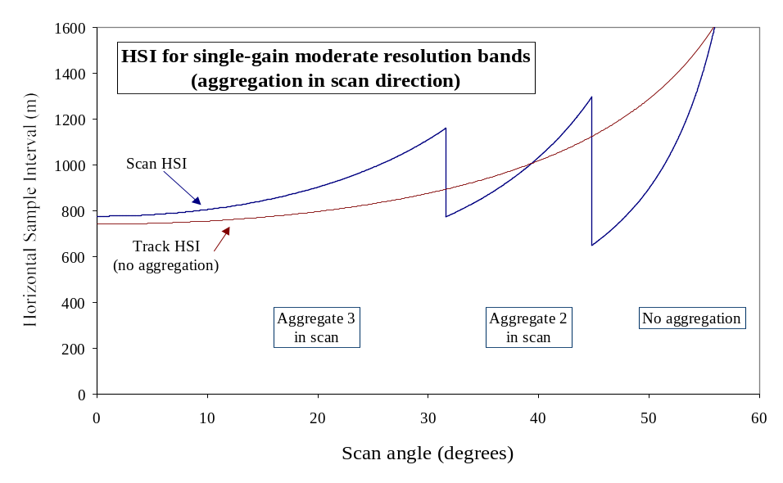
Figure 1. Horizontal sample interval (HIS) in the track and scan direction as a function of VIIRS scan angle.
Agg 3 Zone
Start End
Agg 2 Zone
Start End
No Agg Zone
Start End
Figure 2. Relative sample sizes at the beginning and end of each aggregation zone.
The best time to perform this activity is in the early post-launch checkout phase of the mission after the calibration of the instrument has stabilized. The primary approach to perform this characterization is to acquire the same ground features in different aggregation modes at similar scan angles. For example, a desert location would be acquired at the scan angle in aggregation zone 2 both with nominal two pixel aggregation and then later in the no aggregation mode (by using the engineering data mode of the instrument). Primary ground features of interest are snow, ice, vegetation, persistent thermal anomalies and barren surfaces. The acquisition strategy will try to both minimize the amount of data that needs to be acquired in diagnostic (engineering)mode. It will also try to minimize the amount of time between acquisitions to limit BRDF effects and any temporal changes in the scenes. The acquisition strategy will also need to be flexible to allow for a cloud free and clear atmosphere (low aerosol) data to be acquired. Once the appropriate scenes are acquired, the data will be processed through the EDR algorithms and the impact on the products of the different aggregation modes will be assessed. This work will be conducted in association with experts in the Land PEATE (e.g., Robert Wolfe, Ranga Myneni, per verbal agreements) who have assess geolocation and gridding issues in the MODIS Land program.

Return to Product List

Team Management

Overall Land validation program management and responsibility is provided by J. Privette (NCDC). Co-lead and NASA NPP/MODIS Land Science Team liaison will be Chris Justice (Univ. of Maryland). The team routinely communicates through the existing VIIRS Land “Cross Agency” telecon (biweekly) in addition to ad hoc communications. The Team is currently in discussion with the NPOESS prime contractor on a workable approach to appropriate communication, roles and responsibilities. The Team expects to reach an agreement in the Summer of 2009.

The Land Team will meet face-to-face annually in splinters to other meetings (e.g., VOAT, NASA NPP Science Team, AGU, IGARSS, AMS). Team members are requested to attend at least one VOAT meeting per year, and call-in to the second. Further, team members support NGST Technical Interchange Meetings (TIMs) as appropriate. Team members are also requested upon occasion to support NOAA’s response to Engineering Change Requests (ECRs) or other program documents. Team members are responsible for providing quarterly reports on expenditures, progress, and activities.

Operational User Outreach

It is critical that VIIRS Land products be both operationally viable and meet quantitative specifications. We will work closely with operational users to address these needs in that order. Specifically, we will coordinate a “hand-holding” approach with the Joint Center for Satellite Data Assimilation (JCSDA; POC: Mike Ek) to both develop an early evaluation plan and then to carefully track their early trials with VIIRS data. The JCSDA, which includes participation from DoD, NASA and NOAA, will help identify issues in albedo, LST, VI and snow cover. Later, the JCSDA will incorporate the initial quarterly Surface Type maps. We will aggressively work with the IPO and prime contractor to ensure that data problems are addressed quickly, and we will lend our technical expertise to help discover and resolve underlying problems. We will maintain a similar relationship with the U.S. Forest Service to address fire product issues. We will work through the CU/CIRES institute to identify an appropriate user for Ice Surface Temperature / Sea Ice Characterization EDRs. We will continue to look for other potential early operational users of all VIIRS Land EDRs.

General Schedule

March 2008 – VIIRS Land validation plan (v0.1) delivered to IPO
January 2009 – VIIRS Land Validation Plan (v1) delivered to IPO
April 2009 – VIIRS Land Validation Plan (v2) delivered to IPO
Spring-Fall 2009 – Initial Tests with VIIRS Proxy Data Sets
Field Campaign at CRN Site
Characterize SurfRad and CRN Site Heterogeneity
Spring-Fall 2010 – Follow-up Tests with VIIRS Proxy Data Sets
Field Campaign at SurfRad Site
Characterize SurfRad and CRN Site Heterogeneity
December 2010 – Deliver Complete SPEC
January 2011– NPP Launch
Summer 2011 – Intensive Cal/Val Begins

appendix a.

NPOESS System Specification information and
additional validation issues under consideration by Prime contractor

Surface Albedo EDR

The NPOESS specification document (Sys Spec (SY15-0007), rev N) section 40.5.2 defines the surface albedo EDR, lists the conditions of production of this EDR and provides specifications for its performance.

Surface albedo is defined as the total amount of solar radiation in the 0.4 to 4.0 micron band reflected by the Earth’s surface into an upward hemisphere (sky dome), including both diffuse and direct components, divided by the total amount incident from this hemisphere, including both direct and diffuse components. This EDR is required during daytime only and under clear conditions only. This is an instantaneous, not a time-averaged, measurement. The performance is specified for the horizontal cell defined for this EDR. The data product is retrieved and reported to the user at the higher resolution reporting interval specified.

This EDR will not be produced under "probably clear" or "probably cloudy" conditions indicated by the cloud mask. This EDR will be produced under Exclusion conditions, except for the Solar Zenith Angle Exclusion condition, but without performance specifications.

This EDR will be produced from all nominal NPOESS orbits, but the measurement accuracy for a terminator orbit will be degraded due to VIIRS calibration limitations for a terminator orbit. The terminator orbit is not included in computing the maximum local average revisit time.

Units: Dimensionless

Paragraph | Subject | Specified Value
 | a. Horizontal Reporting Interval
40.5.2-1 | 1. Edge of Swath | 1.6 km
40.5.2-13 | 2. Nadir | 0.75 km
40.5.2-2 | b. Horizontal Cell Size | 4 km
40.5.2-3 | c. Horizontal Coverage | Global
40.5.2-4 | d. Measurement Range | 0 - 1.0 Units of Albedo
40.5.2-5 | e. Measurement Accuracy | 0.03 Units of Albedo
40.5.2-6 | f. Measurement Precision | 0.02 Units of Albedo
40.5.2-7 | g. Long Term Stability | 0.01 Units of Albedo
40.5.2-8 | h. Mapping Uncertainty, 3 Sigma | 1.5 km
40.5.2-9 | i. Max Local Average Revisit Time | 24 hrs, Daytime and Clear Only
40.5.2-11 | j. Latency | NPP - 150 min.  NPOESS - 28 min.
 | l. Degraded Measurement Conditions:
40.5.2-15a | 1. Measurement Accuracy If Solar Zenith Angle 65 to 85 deg | 0.04 Units of Albedo
40.5.2-15b | 2. Measurement Precision If Solar Zenith Angle 65 to 85 deg | 0.04 Units of Albedo
40.5.2-15c | 3. Over ocean with calcite concentration due to coccolithophores greater than or equal to 0.3 mg/m³. | 0.1 Units of Albedo
40.5.2-15d | 4. Regions containing sea ice | 0.3 Units of Albedo
 | m. Excluded Measurement Conditions:
40.5.2-14a | 1. Solar Zenith Angle > 85 deg
40.5.2-14b | 2. Aerosol Optical Thickness > 1.0
40.5.2-14c | 3. With scattering error greater than what would exist at a point 6 milliradians away from the VIIRS Bright Target.

The surface albedo EDR is a global product required over land, ocean and sea ice. The validation of this product will therefore leverage methodologies and data collections appropriate for each biome.

Land Surface Temperature EDR

Validation of NPOESS System Specification for the land Surface type EDR

The two measures of performance for the LST EDR are accuracy and precision, which are shown by the shaded section in Table 1 below. The definition of LST EDR and the System Spec table have been taken from Paragraph 40.6.1 in Appendix D of the NPOESS System Specification, Revision N (SY15-0007).

Land surface temperature (LST) is defined as the skin temperature of the uppermost layer of the land surface. This EDR is required only for horizontal cells where the cell and all cells adjacent to it are categorized as "confidently clear" by the cloud mask. This EDR will be produced under the "probably clear" or "probably cloudy" conditions indicated by the cloud mask or under Exclusion conditions, except for Fire indicated by the cloud mask, but without performance specifications. This EDR also provides temperature measurements for inland (navigable waters) and coastal water regions. The measurement accuracy and precision requirements shall be applicable only within a given surface type.

Table 1. NPOESS System Specification for the LST EDR
Paragraph | Subject | Specified Value | NPP Exclusion
 | a. Horizontal Cell Size
40.6.1-1 | 1. Nadir | 0.75 km
40.6.1-12 | 2. Edge of Swath | 1.3 km
40.6.1-2 | b. Horizontal Reporting Interval | HCS
40.6.1-3 | c. Horizontal Coverage | Land
40.6.1-4 | d. Measurement Range | 213 K - 343 K
40.6.1-5 | e. Measurement Accuracy | 2.4 K
40.6.1-6 | f. Measurement Precision | 0.5 K
40.6.1-7 | g. Mapping Uncertainty, 3 Sigma | 1.5 km
40.6.1-8 | h. Max Local Average Revisit Time | 6 hrs | X
40.6.1-10 | i. Latency | NPP - 140 min.  NPOESS - 28 min.
40.6.1-14 | l. Clear Measurement Precision Degradation Condition: Satellite zenith angle greater than 40 degrees | 1.5 K
40.6.1-13 | k. Excluded Measurement Condition:
40.6.1-13a | 1. Aerosol Optical Thickness > 1.0
40.6.1-13b | 2. Thin cirrus as indicated by Cloud Mask Think Cirrus Flag
40.6.1-13c | 3. Fire as indicated by Cloud Mask Fire Flag

The quality metrics in 40.6.1-5 and 40.6.1-6 will be validated. In addition, the quality metrics for degraded condition in 40.6.1-14 will be characterized.

Validation of NPOESS System Specification for the land Surface Temperature EDR

Discussion of Requirements
The NPOESS specification document (Sys Spec (SY15-0007), rev N) section 40.6.1 defines the VIIRS Land Surface Temperature (LST) EDR and lists the conditions of production of this EDR and provides specifications for its performance. The LST EDR consists of land surface temperature values produced at VIIRS moderate resolution within the Horizontal Cell Size of 1.3 km under non-cloudy conditions for both day and night over all 17 IGBP surface land types including inland (navigable waters) and coastal water regions. The measurement performance requirements for the LST EDR are 2.4 K in accuracy and 0.5 K in precision. Under Clear Measurement Precision Degradation Condition: satellite zenith angle greater than 40 degrees, the requirement is 1.5 K. Exclusion conditions are listed for Aerosol Optical Thickness (AOT), Thin Cirrus, and Active Fire pixels. The AOT exclusion is to be based on the 550 nm slant path AOT greater than 1.0. For scoring against the performance requirement, the accuracy and precision will be computed with the entire data set over all the IGBP land types. However, the performance will also be determined for each of the land type stratification if sufficient match-up data are available for each of the stratification.

The LST regression coefficients will be tuned after sensor characterization before launch probably with global synthetic data. During intensive Cal/Val, quality in-situ data will be matched up with VIIRS LST EDR retrievals produced by the IDPS. LST validation and on-orbit training of the regression coefficients will require several years worth of match-up data.

Vegetation Index and Surface Reflectance
Validation of NPOESS System Specification for the Vegetation Index EDR and Surface Reflectance IP

Discussion of Requirements

The NPOESS specification document (Sys Spec (SY15-0007), rev N) section 40.6.2 defines the vegetation index EDR, lists the conditions of production of this EDR and provides specifications for its performance.

Normalized difference vegetation index (Top of the Atmosphere) is most directly related to absorption of photosynthetically active radiation, but is often correlated with biomass or primary productivity. Red spectral measurements are sensitive to the chlorophyll content of vegetation and the near IR to the mesophyll structure of leaves. The normalized ratio (IR-Red)/(IR+ Red) has a close relationship with the photosynthetic capacity of specific vegetation types.

NDVI is defined as follows:

NDVI = (I2_{TOA} - I1_{TOA}) / (I2_{TOA} + I1_{TOA})

where spectral bands I1 and I2 are 600 - 680 nm and 845.5 - 884.5 nm, respectively. The TOA subscripts indicate that the values used are Top-of-Atmosphere reflectances in the respective bands.

This product also contains a Top of the Canopy Enhanced Vegetation Index (EVI) which is defined as

EVI = (1 + L)*((I2_{TOC} - I1_{TOC})/(I2_{TOC} - C1*M3_{TOC}+ C2*I1_{TOC} +L))

where L, C1 and C2 are constants and M3 is the band between 478 - 498 nm. The TOC subscripts indicate that the values used are Top-of-Canopy reflectances in the respective bands. The M3 band has twice the cell size as the I1 and I2 bands, so its value is applied to 4 horizontal cells. The requirements below apply only for horizontal cells that are classified as "confidently clear" by the cloud mask. The terminator orbit is not included in computing the maximum local average revisit time. This EDR will be produced under the "probably clear" or "probably cloudy" conditions indicated by the cloud mask, but without performance specifications. This EDR will not be produced under the Solar Zenith Angle Exclusion condition, but will be produced under the Aerosol Optical Thickness Exclusion condition, but without performance specification.

Paragraph | Subject | Specified Value
 | a. Horizontal Cell Size
40.6.2-1 | 1. Edge of Swath | 0.8 km
40.6.2-15 | 2. Nadir | 0.375 km
40.6.2-2 | b. Horizontal Reporting Interval | HCS
40.6.2-3 | c. Horizontal Coverage | Land
 | d. Measurement Range
40.6.2-4a | 1. NDVI Units | -1 to +1
40.6.2-4b | 2. EVI Units | -1 to +1
40.6.2-5 | e. Measurement Accuracy | 0.016 NDVI Units
40.6.2-6 | f. Measurement Precision | 0.02 NDVI Units
40.6.2-7 | g. Long Term Stability | 0.01 NDVI Units
 | h. Mapping Uncertainty, 3 Sigma
40.6.2-8a | 1. Nadir | 0.4 km
40.6.2-8b | 2. Edge of Swath | 1.5 km
40.6.2-9 | i. Max Local Average Revisit Time | 24 hrs, Daytime Only
40.6.2-11 | j. Measurement Uncertainty for EVI | 0.11 Units of EVI
40.6.2-12 | k. Long Term Stability (C) | 0.01 NDVI Units
40.6.2-13 | l. Latency | NPP - 140 min.  NPOESS - 28 min.
 | m. Measurement Degradation Conditions:
40.6.2-16c | 3. EVI Measurement Uncertainty if Solar Zenith Angle 65 to 85 deg | 0.2 EVI Units
 | o. Measurement Exclusion Conditions:
40.6.2-17a | 1. Solar Zenith Angle > 85 deg, for both NDVI and EVI
40.6.2-17b | 2. Aerosol Optical Thickness > 1.0, for EVI

Validation of NPOESS System Specification for the Vegetation Index EDR and Assessment of the Surface Reflectance IP

Discussion of Requirements

The NPOESS specification document (Sys Spec (SY15-0007), rev N) section 40.6.2 defines the vegetation index EDR, lists the conditions of production of this EDR and provides specifications for its performance. Since the surface reflectance IP is the main input for the TOC EVI validation of this product will be based on the validation of the surface reflectance IP.

Approach to assessment of Surface Reflectance IP

The surface reflectance IP is the key product to many land products and even though there are no explicit requirements for this product an evaluation of the performance of this product is essential to downstream land products. This product provides the atmospheric corrected reflectance which is the reflectance that would be measured in the absence of atmosphere. Besides the Vegetation Index EDR (TOC EVI), It is an input to via the TOC NDVI to the surface type EDR. It is the primary input after gridding for the surface albedo IP which is the basis of the DPSA albedo EDR algorithm. Finally after compositing the surface reflectance is an input to the quarterly surface type IP.

Validation will also use comparisons to ground-level surface reflectance measurements as described for instance in Sharma et al. (2009). These in-situ measurements need to be characterized in terms of their uncertainty and validity for upscaling and comparison to VIIRS footprint retrievals of surface reflectance. The collection of these in-situ measurements will have to be performed during dedicated field campaigns.

Cryosphere Products: Snow Cover and Depth
Validation of NPOESS System Specification for the Snow Cover depth EDR

The Snow Cover/Depth EDR consists of a Snow Binary Map (snow/no snow flag) and a Snow Fraction Map that are produced as day only products over land. The NPOESS/VIIRS System Specification for the Snow Cover/Depth EDR products is shown in the table 1 below which is taken from paragraph 40.6.3 in Appendix D of the NPOESS System Specification. The portions of the table shaded in light gray correspond to requirements imposed upon the Snow Fraction product. Requirements shaded in dark gray apply to the Snow Binary Map product.

Table 1. NPOESS System Specification Requirements for the Snow Cover/Depth EDR
Paragraph | Subject | Specified Value
 | a. Horizontal Cell Size
40.6.3-1a | 1. Nadir | 0.8 km
40.6.3-1b | 2.Edge of Swath | 1.6 km
40.6.3-3a | b. Horizontal Reporting Interval | HCS
40.6.3-4 | c. Snow Depth Ranges | Snow/No Snow
40.6.3-5 | d. Horizontal Coverage | Land
40.6.3-7 | f. Measurement Range | 0 - 100% of HCS
40.6.3-8 | g. Measurement Uncertainty | 10% of HCS (Snow/No Snow)
40.6.3-10 | h. Mapping Uncertainty, 3 Sigma | 1.5 km
40.6.3-12 | i. Max Local Average Revisit Time | 24 hrs Daytime Only
 | j. Binary HCS
40.6.3-14a | 1. Nadir | 0.4 km
40.6.3-14b | 2. Edge Of Swath | 0.8 km
40.6.3-16 | l. Long Term Stability (C) | 10%
40.6.3-17 | m. Latency | NPP - 140 min.  NPOESS - 28 min.
40.6.3-18 | n. Binary Map- Measurement Range | Snow/No Snow
40.6.3-19 | o. Binary Map- Probability of Correct Typing | 90%
40.6.3-21 | p. Measurement Uncertainty Degradation If Solar Zenith Angle 70 to 85 deg | 40% of HCS (Snow/No Snow)
40.6.3-22 | r. Measurement Exclusions:
40.6.3-22a | 1. Snow Fraction Measurement Exclusion Condition: Horizontal Cell Contains Forest Canopy
40.6.3-22b | 2. Binary Map Probability of Correct Typing Exclusion Condition: Snow Fraction 0.2 to 0.7 or Solar Zenith Angle > 60 deg
40.6.3-22c | 3. All Measurements If Aerosol Optical Thickness > 1.0
40.6.3-22d | 4. All Measurements If Solar Zenith Angle > 85 deg

Validation of NPOESS System Specification for the Snow Cover depth EDR

- Discussion of Requirements

The NPOESS specification document (Sys Spec (SY15-0007), rev N) section 40.6.3 defines the Snow Cover/Depth EDR, lists the conditions of production of this EDR and provides specifications for its performance. The Snow Cover/Depth EDR consists of a VIIRS imagery resolution Snow Binary Map (snow/no snow flag) and a VIIRS moderate resolution Snow Fraction Map that are produced as day only products over land. There is no snow depth requirement for the VIIRS Snow Cover EDR.

The Snow Binary Map is required to meet a probability of correct typing (PCT) performance requirement of 90%. Exclusion conditions are listed for Solar Zenith Angle, Aerosol Optical Thickness (AOT) and Snow Fraction thresholds. The AOT exclusion is be based on the 550 nm slant path AOT for both the Snow Binary Map and Snow Fraction Map. The Snow Fraction Map is required to be produced at VIIRS moderate resolution (0.8 km @ nadir). The Snow Fraction Map is based on a 2x2 aggregation of the Snow Binary Map. The uncertainty requirement for the Snow Fraction Map is 10%. The uncertainty for degraded conditions associated with Solar Zenith angles between 70 and 85 degrees is 40%. Exclusion conditions are listed for Solar Zenith Angle, Aerosol Optical Thickness. Retrievals will be performed for both products for solar zenith angles to 85 degrees.

- Approach to Validation

A comprehensive two staged approach for calibration/validation of VIIRS Snow Cover is described in the "Cryosphere Products Snow Cover and Depth" section of this document. The metric used to evaluate the performance of the Snow Binary Map is the total probability of correct typing (PCT) as defined according to the NPOESS System Specification (40.1.3.3).

The Snow Fraction uncertainty is computed according to the definition of uncertainty defined in the NPOESS System Specification (40.1.6). The cells included in the performance typing must be clear and not associated with an exclusion condition.

Cryosphere Products: Ice Surface Temperature and Sea Ice Characterization

Validation of NPOESS System Specification for Ice Surface Temperature EDR

The Ice Surface Temperature EDR (IST EDR) consists of ice surface temperature values produced for both day and night over snow/ice covered oceans. The NPOESS/VIIRS System Specification for the IST EDR product is shown in table 1 which is taken from paragraph 40.7.3 in Appendix D of the NPOESS System Specification. The portions of the table shaded in gray correspond to the performance and exclusion condition requirements for the IST EDR.

Table 1. NPOESS System Specification Requirements for the IST EDR
Paragraph | Subject | Specified Value, Clear [VIIRS]
 | a. Horizontal Cell Size (HCS)
40.7.3-1 | 1. Nadir | 0.8 km
40.7.3-9 | 2. Worst Case | 1.6 km
40.7.3-2 | b. Horizontal Reporting Interval | 1.0 km
40.7.3-3 | c. Horizontal Coverage | Ice-covered Oceans
40.7.3-4 | d. Measurement Range | 213 K - 275 K
40.7.3-5 | e. Measurement Uncertainty at Horizontal Reporting Interval | 0.5 K
40.7.3-6 | f. Mapping Uncertainty, Nadir, 3 Sigma | 0.4 km
40.7.3-7 | g. Maximum Local Average Revisit Time | 24 hrs
40.7.3-10 | h. Latency | NPP - 140 min.  NPOESS - 28 min.
40.7.3-11 | i. Measurement Exclusion Condition:
40.7.3-11a | 1. Aerosol Optical Thickness > 1.0
40.7.3-11b | 2. Inland waters
40.7.3-11c | 3. Coastal waters
40.7.3-11d | 4. Thin cirrus as indicated by Cloud Mask Thin Cirrus Flag

Validation of NPOESS System Specification for Ice Surface Temperature EDR

- Approach to Performance Validation

A two level approach for calibration/validation of VIIRS IST EDR is described in the "Cryosphere Products Ice Surface Temperature and Sea Ice Characterization” section of this document. The metric used to evaluate the performance of the IST EDR is the measurement uncertainty as defined according to the NPOESS System Specification (40.7.3). The measurement uncertainty is computed according to the definition of uncertainty defined in the NPOESS System Specification (40.1.6). The IST EDR is dependent on the Sea Ice Concentration Retained Intermediate Product (SIC RIP) for identification of snow/ice cover pixels over oceans. Although there are no NPOESS System Specifications for the Ice Concentration RIP and Reflectance/Temperature RIP, ice concentration and tie point performances must be assessed in order to validate the IST EDR due to the dependence of the IST algorithm on those RIPs. Determination of recommended degradation and exclusion thresholds for the Thermal Contrast is to be determined during Cal/Val. Likewise, thresholds for snow depth degradation and exclusion are to be determined during Cal/Val. The SIC RIP must be requested and archived by NSIPS since it is not a deliverable product that is archived to CLASS. Note that the SIC RIP and other RIPs will not be available after Calibration and Validation is completed.

Validation of NPOESS System Specification for Sea Ice Age EDR
- Discussion of Requirements

The NPOESS specification document (Sys Spec (SY15-0007), rev N) section 40.7.8 defines the Sea Ice Age (SIA) EDR and lists the conditions of production of this EDR and provides specifications for its performance. The Sea Ice Age EDR (SIA EDR) is an ice age classification map that contains classifications for Ice -free, New/Young ice and All Other ice categories. It is produced for both day and night over oceans. The SIA EDR algorithm produces results at aggregated to VIIRS moderate resolution (0.8 km @ nadir). The performance requirement for the SIA EDR is for 70% Probability of Correct Typing for Ice-free, New/Young ice and All Other ices for confidently clear conditions. The EDR is produced for probably clear and probably cloudy pixels but the performance is not reported for such cells. Probability of Correct Typing requirements are reduced to 60% for degradation conditions that are listed for low Thermal Contrast (1.5 K to 2.2 K between Ice and Open Water) and for Snow Depths between 6 cm to 10 cm. Exclusion conditions are listed for Aerosol Optical Thickness (AOT), Sun Glint, low ice/ocean water Thermal Contrast and Snow Depth. These degradation and exclusion conditions are identified as quality flags contained in the SIA EDR data records. The AOT exclusion is to be based on the 550 nm slant path AOT. The production of the product is limited to Latitude ≥ 36 Deg N or Latitude ≥ 50 Deg S and fill values are used otherwise. The geolocation of a 2x2 cell is based on VIIRS moderate resolution SDR.
- Approach to Validation
A two level approach for calibration/validation of VIIRS SIA EDR is described in the "Cryosphere Products Ice Surface Temperature and Sea Ice Characterization" section of this document. The metric used to evaluate the performance of the Sea Ice Age product is the total probability of correct typing (PCT) as defined according to the NPOESS System Specification (40.1.3.3). The Sea Ice Age EDR algorithm requires inputs that are generated by several precursor algorithms that comprise the Sea Ice Characterization algorithm suite (Sea Ice Quality, Surface Temperature RIP, and Sea Ice Concentration).
The Sea Ice Quality algorithm generates two Retained IPs (Sea Ice Quality Flags RIP and Sea Ice Quality Weights RIP). These RIPs are required as input to the Surface Temperature RIP (ST IP) algorithm that generates the Surface Temperature RIP product. This product (ST IP) contains values of surface temperatures that have been generated at VIIRS imagery resolution using an IST EDR like regression algorithm. The Sea Ice Quality algorithm may be run in two modes VCM mode and Cloud Optical Thickness (COT) mode. The operational default mode is to run in the VCM mode. In this mode the cloud confidence from the VIIRS Cloud Mask IP algorithm with be used to set the cloud confidence flags used by the Sea Ice Characterization algorithm suite. The COT mode allows use of Cloud Optical Thickness data to determine the cloud confidence. In the event that it is determined during Cal/Val that the VCM IP cloud confidence performance is not adequate over bright snow/ice covered surfaces.
The ST IP algorithm generates surface temperature results for both ice surface and ice free ocean but the retrievals over both surfaces are based on regression coefficients trained against only snow/ice surfaces. The Surface Temperature RIP data are required as input to the Sea Ice Concentration algorithm.
The Sea Ice Concentration algorithm generates a Sea Ice Reflectance/Temperature RIP and a Sea Ice Concentration RIP. The Reflectance/Temperature RIP contains the ice and water tie points. The Sea Ice Concentration algorithm has two algorithm modes: adjustable tie point search window mode and fixed tie point search window mode. The IDPS operational default mode will be to run Sea Ice Concentration with the adjustable search window mode. If an appropriate fixed window size can be determined during Cal/Val then use of a fixed window can be considered for the operational IDPS production.
Although there are no NPOESS System Specifications for the Surface Temperature RIP, Ice Concentration RIP and Reflectance/Temperature RIP the surface temperatures, ice concentration and tie point performances must be assessed in order to validate the Sea Ice Age EDR. Determination of recommended degradation and exclusion thresholds for the Thermal Contrast is to be determined during Cal/Val. Likewise, thresholds for snow depth degradation and exclusion are to be determined during Cal/Val.
- Correlative Truth Needed
The sources of correlative truth data for matchup datasets for the "Product Verification and Initial Validation" and "Comprehensive Validation" have been previously described in the Cryosphere Products Ice Surface Temperature and Sea Ice Characterization section. In-situ or derived sea ice thickness and snow depth on sea ice are necessary for validation of the IDPS operational Sea Ice Age EDR. Sea ice thickness or ice age from multiple sources such as digitized Ice Charts from the National Ice Centre and ice thicknesses derived from analysis of available satellite data such as CyroSat2, AMSR-E, SSM/I and Landsat will be required for validation of the operational Sea Ice Age EDR probability of correct typing performance.
While granule level SDRs, EDRs and deliverable IP products are archived to and retrievable from CLASS, Retained IP products such as the Surface Temperature RIP, Aerosol Optical Thickness RIP and Sea Ice Concentration RIP are not archived from CLASS. Retained IP products must be archived by the Cal/Val team in order to be available for comprehensive validation. Note that the SIC RIP and other RIPs will not be available after Calibration and Validation is completed.
Validation of NPOESS System Specification for Sea Ice Age EDR

The Sea Ice Age EDR (SIA EDR) is an ice age classification map that contains classifications for Ice -free, New/Young ice and All Other ice categories. It is produced for both day and night over oceans. The NPOESS/VIIRS System Specification for the SIA EDR product is shown in table 1 which is taken from paragraph 40.7.8 in Appendix D of the NPOESS System Specification. The portions of the table shaded in gray correspond to the performance, degradation and exclusion condition requirements for the SIA EDR.

Table 1. NPOESS System Specification Requirements for the SIA EDR
Paragraph | Subject | Specified Value
 | a. Horizontal Cell Size (Ice Age)
40.7.8-1a | 1. Clear | 2.4 km
40.7.8-2 | b. Horizontal Reporting Interval | HCS
40.7.8-3 | c. Horizontal Coverage | Oceans
 | d. Measurement Range
40.7.8-4a | 1. Ice Age Classes, Clear | Ice-free, New/Young ice, All other ice
 | e. Probability of Correct Typing (Ice Age)
40.7.8-6a | 1. Ice-free | 70%
40.7.8-6b | 2. New/Young | 70%
40.7.8-6c | 3. All other ice | 70%
40.7.8-8 | g. Mapping Uncertainty, 3 Sigma | 1.5 km
40.7.8-9 | h. Max Local Average Revisit Time | 24 hrs
40.7.8-12 | j. Latency | NPP - 150 min.  NPOESS - 8 hr
 | m. Degraded Clear Measurement Condition for Probability of Correct Typing:
40.7.8-15a | 1. Thermal Contrast 1.5 K (SYS-TBR-026) to 2.2 K Between Ice and Open Water | 60% (SYS-TBR-025)
40.7.8-15b | 2. Snow Fall 6 cm to 10 cm (SYS-TBR-028) | 60% (SYS-TBR-027)
 | n. Excluded Clear Measurement Condition for Probability of Correct Typing:
40.7.8-16a | 1. Thermal Contrast < 1.5 K (SYS-TBR-029) Between Ice and Open Water
40.7.8-16b | 2. Snow Fall > 10 cm (SYS-TBR-030)
40.7.8-16c | 3. Aerosol Optical Thickness > 1.0
40.7.8-16d | 4. Sun Glint

- Discussion of Requirements

The System Specification states that the SIA EDR is required to be produced at an aggregated HCS resolution of at least 2.4 km. The SIA EDR algorithm produces results at aggregated to VIIRS moderate resolution (0.8 km @ nadir). The performance requirement for the SIA EDR is for 70% Probability of Correct Typing for Ice-free, New/Young ice and All Other ices for confidently clear conditions. The EDR is produced for probably clear and probably cloudy pixels but the performance is not reported for such cells. Probability of Correct Typing requirements are reduced to 60% for degradation conditions that are listed for low Thermal Contrast (1.5 K to 2.2 K between Ice and Open Water) and for Snow Depths between 6 cm to 10 cm. Exclusion conditions are listed for Aerosol Optical Thickness (AOT), Sun Glint, low ice/ocean water Thermal Contrast and snow depth. These degradation and exclusion conditions are identified as quality flags contained in the SIA EDR data records. The AOT exclusion is to be based on the 550 nm slant path AOT. The performance of the SIA EDR is to be verified for cells that are defined as clear, over oceans. The production of the product is limited to Latitude ≥ 36 Deg N or Latitude ≥ 50 Deg S and fill values are used otherwise. If the entire scan is between 36 deg N Latitude and 50 degrees S Latitude, no product is produced. Since the SIA EDR product is produced as an aggregated of 2x2 imagery resolution pixels, criteria for setting quality flags for an aggregated cell based on imagery resolution surface temperature data are as follows:
- The product is flagged as being in a degraded condition for Thermal Contrast if 2 or more imagery resolution pixels between open water and ice are between 1.5 degrees Kelvin and 2.2 degrees Kelvin.
- The product is flagged as being in a excluded condition for Thermal Contrast if 2 or more imagery resolution pixels between open water and are less than 1.5 degrees Kelvin.

The geolocation of a 2x2 cell is based on VIIRS moderate resolution SDR.

- Specific Assumptions

It is assumed that the VIIRS sensor will produce SDRs that satisfy the sensor requirements and geo-location requirements for the I1, I2, I5, M15 and M16 bands which are used in the by the SIA EDR algorithm. It is also assumed that the performance of the VIIRS Cloud Mask IP cloud confidence and will meet NPOESS System Specifications to allow identification of clear, sea ice pixels for evaluating performance. The Sea Ice Age algorithm is dependent on a number of other input products. The error characteristics of these precursor products are assumed to be sufficiently characterized and within margin to allow the Sea Ice Age EDR to meet its Probability of Correct Typing specifications. Knowledge of snow depth on sea ice is particularly important.
A two level validation strategy has been previously described in the "Cryosphere Products Ice Surface Temperature and Sea Ice Characterization" section as consisting of a "Product Verification and Initial Validation" that relies upon comparative analysis with analogs derived independently from other sensors such as AVHRR, and MODIS. It is assumed that these products as well as Landsat imagery will be available for some duration of the NPP and NPOESS mission to perform such analysis. It also assumed that digitized ice chart data from the sources previously described will be available for performance and comparative analysis. Is has been discussed that in order to perform validation to a level that is scientifically defendable a "Comprehensive Validation" strategy is required that includes on-site field work combined with aerial (P3 and or UAV) over flights instrumented with appropriate narrow band radiometers. It is assumed that "Comprehensive Validation" will be performed during intensive Cal/Val and beyond.
It is also assumed that the full list of intermediate product data required to execute the SIA EDR algorithm in a post-operational environment will be obtained routinely by NSIPS from the IDPS and can be delivered based upon request. It is further assumed that perfect Configuration Management will be maintained by IDPS on LUTs, thresholds, and other tunable parameters, i.e. not changes will occur without the approval of the appropriate CM board. Finally, since the goal of this section of the SIA EDR Cal/Val Plan is to assess the SIA EDR performance against NPOESS Sys Spec requirements, it is assumed that the SIA EDR product satisfying these performance requirements will satisfy the requirements of the NPOESS user community.

- Approach to Validation

A two level approach for calibration/validation of VIIRS SIA EDR is described in the "Cryosphere Products Ice Surface Temperature and Sea Ice Characterization" section of this document. The performance of the SIA EDR algorithm will be routinely examined to identify VIIRS granules that have performed poorly and well under various seasonal and geographic conditions. The metric used to evaluate the performance of the SIA EDR is the Probability of Correct Typing as defined according to the NPOESS System Specification (40.7.3).and is computed according to the definition defined in section 14.6-3 of this document. The truth derived are from the independent sources previously discussed such as digitized Ice Chart data and/or appropriate field campaign measurements of ice age derived from sea ice thickness transects or points. Any point or transect measurement truth data must be used with consideration of the representativeness of the satellite field of view taken into account. Since the VIIRS Sea Ice Age EDR algorithm retrieves sea ice age using the VIIRS I1 and I2 TOA reflectances during day, collection of information related to sub-pixel surface features such as the fraction of melt ponds, leads snow depth on ice and surface roughness will be important to characterize as part of any comprehensive validation effort. In addition, it will be important to also characterize the snow grain size and liquid water content, brine pocket and air bubble size and number density and other physical parameters that effect the Inherent Optical Properties (IOPs) used in the computation of forward TOA reflectances for a snow/sea ice surface. This will be important for checking the validity of the Sea Ice Modeled Reflectance Lookup Table using actual in situ based physical parameters. Night and terminator retrievals of Sea Ice Age are dependent on a heat balance that primarily depends on surface temperatures retrieved by the Surface Temperature RIP algorithm based on the VIIRS I5, M15 and M16 bands. Granulated auxiliary data such as NCEP surface air temperature, humidity and wind speed used by the SIA algorithm will not be available for request from IDPS to NSIPS. The granulated ancillary data used as input in the operational IDPS system are spatially and temporally interpolated. Efforts to characterize algorithm anomalies base on non-IDPS equivalent gridded ancillary data will require characterization of the ancillary data differences.

Calibration/Validation performed will require that the Sensor Data Records and Intermediate Product data be available for processing. The Sea Ice Age EDR algorithm requires inputs that are generated by several precursor algorithms that comprise the Sea Ice Characterization algorithm suite (Sea Ice Quality, Surface Temperature RIP, and Sea Ice Concentration). The Sea Ice Quality algorithm generates two Retained IPs (Sea Ice Quality Flags RIP and Sea Ice Quality Weights RIP). These RIPs are required as input to the Surface Temperature RIP (ST IP) algorithm that generates the Surface Temperature RIP product. This product contains values of surface temperatures that have been generated at VIIRS imagery resolution using an IST EDR like regression algorithm. The STIP algorithm generates surface temperature results for both ice surface and ice free ocean but the retrievals over both surfaces are based on regression coefficients trained against only snow/ice surfaces. The Surface Temperature RIP data are required as input to the Sea Ice Concentration algorithm. The Sea Ice Concentration algorithm generates a Sea Ice Reflectance/Temperature RIP and a Sea Ice Concentration RIP. The Reflectance/Temperature RIP contains the ice and water tie points.

The SDRs and Deliverable IP granule level data are made available via automated ftp push to NSIPS from IDPS/DDS by a subscription process to the IDPS/DDS. While deliverable products such as the SDRs and IP categorized as "Deliverable" IPs are available from IDPS/DDS for 24 hours and are also archived and to CLASS, the Retained IP data such as the AOT IP are available from IDPS/DDS only for a limited number of hours (3 hours) and are not archived to CLASS. These Retained IPs will be available at NSIPS for 48 hours, for instance the AOT RIP and the Ice Concentration RIP.
The Sea Ice Quality algorithm may be run in two modes VCM mode and Cloud Optical Thickness (COT) mode. The operational default mode is to run in the VCM mode. In this mode the cloud confidence from the VIIRS Cloud Mask IP algorithm with be used to set the cloud confidence flags used by the Sea Ice Characterization algorithm suite. The COT mode allows use of Cloud Optical Thickness data to determine the cloud confidence. In the event that it is determined during Cal/Val that the VCM IP determined cloud confidence performance is not adequate over bright snow/ice covered surfaces.

The Sea Ice Concentration routine may also be run in two algorithm modes: adjustable tie point search window mode and fixed tie point search window mode. The IDPS operational default mode will be to run Sea Ice Concentration with the adjustable search window mode. If an appropriate fixed window size can be determined during Cal/Val then use of a fixed window can be considered for the operational IDPS production. The Sea Ice Concentration algorithm is based on a tie point method. The water and ice tie points are determined by histograms of the I1, I2 reflectance and surface temperature collected in sliding windows. If a water or ice tie point can not be determined then tie points are assigned based on granule sized window. If no granule based tie points are found then defaults are assigned. Although there are no NPOESS System Specifications for the Surface Temperature RIP, Ice Concentration RIP and Reflectance/Temperature RIP the surface temperatures, ice concentration and tie point performances must be characterized in order to validate the Sea Ice Age EDR. The snow depth on sea ice, melt pond and lead fraction are factors that affect the determination of tie points used to determine the Ice Concentration RIP ice fractions.

Determination of recommended degradation and exclusion thresholds for the Thermal Contrast may also be determined during Cal/Val. Likewise, thresholds for snow depth degradation and exclusion may also be determined during Cal/Val.

- Correlative Truth Needed

The sources of correlative truth data for matchup datasets for the "Product Verification and Initial Validation" and "Comprehensive Validation" have been previously described in the Cryosphere Products Ice Surface Temperature and Sea Ice Characterization section.

It is required to identify the excluded conditions that are listed in Table 4 for determining the SIA EDR performance.

Table 4. SIA EDR Exclusion Conditions defined in the NPOESS Sys Spec.
Product | Exclusion Conditions | Identification Method
SIA EDR | Cloud Confidence Exclusion: Performance is excluded for confidently cloudy, probably cloudy and probably clear pixels and if any other cloud mask elements flagged as cloudy (i.e. thin cirrus) | Quality flags for Cloud Confidence
 | AOT Exclusion Condition: 550 nm slant path AOT > 1.0 | Quality flag for AOT exclusion
 | Land Only Processing Exclusion: SIA is produced only over ocean | Quality flags for Land/Ocean/Coast
 | Sun Glint Exclusion: If the sun glint flag passed from the VCM IP quality flag for sun glint is set then performance excluded. | Sun Glint Quality Flag

- Computed QC metrics

SIA EDR performance metric is the measurement uncertainty and is evaluated using the equations for these performance measures that are defined in the NPOESS System Specification and described in the Snow Cover validation section. The uncertainty is reported for clear cells. A cell is defined as clear if the cloud mask indicates confidently clear and the thin cirrus detection flag is not set for that horizontal cell. The SIA is computed only for ocean pixels. The Ice Concentration RIP is used by the SIA EDR algorithm to identify ice based on a 10% ice fraction threshold.

- Correlative data QC metrics

Quality Control metrics affecting the computed performance metrics listed in section titled "Approach to Validation” are the SIA EDR quality flags that are defined in the Operational Algorithm Description Document for VIIRS Sea Ice Age EDR. The quality flags from that document are listed in table 5.

Table 5. SIA EDR QC Metrics

Product | QC Metric
STIP RIP | STIP RIP quality flags for retrieval quality
Sea Ice Quality Weights RIP | Sea Ice Quality Weights indicate relative quality
Sea Ice Concentration RIP | Ice fraction vs. truth ice fraction
Sea Ice Concentration Reflectance/Temperature RIP | Water and Ice Tie Points; Search Window Quality
Sea Ice Age EDR | PCT for Ice-free vrs truth ice extent  PCT for New/Young class vrs ice chart truth  PCT for All other ice class vr ice chart truth
Sea Ice Age EDR | SIA EDR QC flags (cloud confidence, exclusion & degradation conditions)

- External QC metrics

n/a

- Integration with other cal/val plans.

Validation of the SIA EDR product will benefit from knowledge of the quantified performance results of the VIIRS Cloud Mask IP (VCM IP) validation plan. SIA errors associated with VCM IP cloud confidence errors over bright surface backgrounds may be estimated from the VCM IP validation. Likewise, identification of ice from ice free oceans is dependent on the performance of the Ice Concentration RIP.

- Related efforts for non-quantitative assessment

Algorithm performance based on non-quantitative comparison approaches must be made for regions due to the lack of reliable in situ data in most sea ice regions. The interactive analysis approached will be performed on a case by case basis. The analysis will focus on obvious algorithm failures that may require a cooperative team effort to identify and assess the root causes. The Ice Concentration RIP, VIIRS Cloud mask, AOT, and solar and sensor view geometry angles information from SDRs , IPs and EDRs must be available in a common projection with that of other independent reference satellite data to allow for detailed comparative analysis.

- Cal/Val Risks

The primary risk associated with a full implementation of this Cal/Val plan not meeting NPOESS requirements is the possible end-of-life or unexpected loss of independent satellite sources for providing collaborative reference truth of ice extent and ice surface temperature. Secondary risks would be associated with the failure to perform the Comprehensive validation described. Also it is crucial that the NSIPS to delivery of required EDR, IP and Retained IP data on a near real-time basis with the resulting loss of data used to analyze individual granules in the IDPS. Failure to capture the data used to generate the IDPS VIIRS SIA EDR results analyses, when needed, could severely impact attempts to isolate errors in the SIA EDR algorithmic logic or failures in the input datasets. Lack of adequate traceability to the IDPS algorithm version and processing coefficients tables, may additionally reduce the confidence and validity of the operationally produced product.

- Cross-Comparisons to Other Sensor/Algorithms

Assistance will be requested from the Land Teams to ensure that the performance adequately addresses product requirements

- Conclusions

Summarize conclusions for this EDR group and note that in the Appendices, the tasks performed by various Cal/Val groups will be broken out by (1) tasks completed by NGAS contractor team with NPOESS funding, (2) tasks conducted by SME –Government team with NPOESS funding, and (3) tasks conducted by SME –Government team with non-NPOESS (other) funding.

Surface Type

Validation of NPOESS System Specification for the Surface Type EDR and Quarterly Surface Type IP

Discussion of Requirements
The NPOESS specification document (Sys Spec (SY15-0007), rev N) section 40.6.4 defines the surface type EDR, lists the conditions of production of this EDR and provides specifications for its performance.
Surface type is defined as one of the seventeen International Geosphere Biosphere Program (IGBP) classes defined below. The requirements below apply in both clear and cloudy conditions. This EDR will be produced under the "probably clear" and "probably cloudy" conditions indicated by the cloud mask, or under Exclusion conditions, but without performance specifications.

SYS040700 Each given area shall be classified as one of the types in Table 40.6.4-1.

Table 40.6.4-1 Land Cover Classifications
Land Cover Class | Definition
1. Evergreen Needleleaf Forests | Lands dominated by woody vegetation with a percent cover >60% and height exceeding 2 meters. Almost all trees remain green all year. Canopy is never without green foliage.
2. Deciduous Needleleaf Forests | Lands dominated by woody vegetation with a percent cover >60% and height exceeding 2 meters. Consists of seasonal, needleleaf tree communities with an annual cycle of leaf-on and leaf-off periods.
3. Evergreen Broadleaf Forests | Lands dominated by woody vegetation with a percent cover >60% and height exceeding 2 meters. Almost all trees and shrubs remain green all year. Canopy is never without green foliage.
4. Deciduous Broadleaf Forests | Lands dominated by woody vegetation with a percent cover >60% and height exceeding 2 meters. Consists of broadleaf tree communities with an annual cycle of leaf-on and leaf-off periods.
5. Mixed Forests | Lands dominated by woody vegetation with a percent cover >60% and height exceeding 2 meters. Consists of tree communities with interspersed mixtures or mosaics of the other four forest types. None of the forest types exceeds 60% of landscape.
6. Closed Shrublands | Lands with woody vegetation less than 2 meters tall and with shrub canopy cover >60%. The shrub foliage can be either evergreen or deciduous.
7. Open Shrublands | Lands with woody vegetation less than 2 meters tall and with shrub canopy cover between 10-60%. The shrub foliage can be either evergreen or deciduous.
8. Woody Savannas | Lands with herbaceous and other understory systems, and with forest canopy cover between 30-60%. The forest cover height exceeds 2 meters.
9. Savannas | Lands with herbaceous and other understory systems, and with forest canopy cover between 10-30%. The forest cover height exceeds 2 meters.
10. Grasslands | Lands with herbaceous types of cover. Tree and shrub cover is less than 10%.
11. Permanent Wetlands | Lands with a permanent mixture of water and herbaceous or woody vegetation. The vegetation can be present in either salt, brackish, or fresh water.
12. Croplands | Lands covered with temporary crops followed by harvest and a bare soil period (e.g., single and multiple cropping systems). Note than perennial woody crops will be classified as the appropriate forest or shrubland cover type.
13. Urban and Built-Up | Land covered by buildings and other man-made structures.
14. Cropland/Natural Vegetation Mosaics | Lands with a mosaic of croplands, forests, shrubland, and grasslands in which no one component comprises more than 60% of the landscape.
15. Snow and Ice | Lands under snow/ice cover.
16. Barren | Lands with exposed soil, sand, rocks, or snow and never have more than 10% vegetated cover during any time of the year.
17. Water Bodies | Oceans, seas, lakes, reservoirs, and rivers. Can be either fresh or salt-water bodies.

SYS040705 The Surface Type EDR shall consist of a determination of surface types based on the last orbit’s data where possible (requires cloud-free pixels, solar zenith angle < 70 deg, and sun glint angle > 36 deg), and redelivery of a Quarterly Surface Types Intermediate Product with 1 km pixels which is updated every 3 months.

Paragraph | Subject | Specified Value
40.6.4-1 | a. Horizontal Cell Size | 1 km
40.6.4-3 | b. Horizontal Reporting Interval | HCS
40.6.4-4 | c. Horizontal Coverage | Land
 | d. Measurement Range
40.6.4-6 | 1. Vegetation/Surface Type | 17 Types Specified in Table 40.6.4-1
40.6.4-7 | 3. Vegetation Cover | 0 - 100 %
40.6.4-8 | e. Measurement Accuracy (Vegetation Cover) | 20%
40.6.4-9 | f. Measurement Precision (Vegetation Cover) | 10%
40.6.4-10 | g. Correct Typing Probability (Vegetation /Surface Type) | 70%
40.6.4-11 | h. Mapping Uncertainty, 3 Sigma | 1.5 km
40.6.4-12 | i. Max Time Between Local EDR Updates | 24 hrs
40.6.4-14 | j. Latency | NPP - 140 min.  NPOESS - 28 min.
40.6.4-15 | k. Excluded Measurement Condition: Aerosol Optical Thickness > 1.0

Validation of NPOESS System Specification for the Surface Type EDR and Quarterly Surface Type IP

The NPOESS specification document (Sys Spec (SY15-0007), rev N) section 40.6.4 defines the surface type EDR, lists the conditions of production of this EDR and provides specifications for its performance.

The surface type EDR and Quarterly surface type IP which is explicitly called for in the NPOESS specifications are closely linked and the validation effort of the Surface Type EDR implies a validation of the Quarterly Surface Type IP.

Approach to Validation

First, validation of the surface type EDR output listed in the NPOESS specification document item 40.6.4-6 which consists of the remapped quarterly surface type IP will be considered below in the section on validation of the quarterly surface type IP. The validation of the vegetation fraction listed in 40.6.4-7, is based on of the surface reflectance IP which produces the atmospherically corrected reflectances used in the computation of the TOC NDVI (M5 and M7 bands). The vegetation fraction is defined as the percentage of the interval defined by minimum NDVI and maximum TOC NDVI the current TOC NDVI corresponds to. Since the yearly maximum and minimum TOC NDVI are based on the accuracy of the TOC NDVI, validating vegetation fraction amounts to validation of the TOC NDVI.

The validation of the surface type flags amounts to the validation of the Quarterly surface type gridded IP. The performance of this product as described in the sections above is entirely controlled by the accuracy and correct sampling of the training sites. Therefore quality control and traceable procedures for training sites determination from high resolution imagery is of paramount importance. This monitoring and collection of training sites once available will be used to evaluate the quarterly surface type in the fashion described in the section above.

